**1. Scenario**

Scenario:

I am a SAP FICO consultant for “Acme Manufacturing Ltd.” The company is expanding and needs to set up a new legal entity (“Acme India Pvt Ltd”). I had tasked to set up master data, entering transactions for August 2025, and preparing financial analytics and reporting.

**2. Tasks**

**2.1 Master Data Creation**

a. Company Code

Company Code: ACIN

Company Name: Acme India Pvt Ltd

Fiscal Year Variant: AC , Posting Period Variant: ACIN (all 12 periods open)

**Steps in SAP: SPRO → Enterprise Structure → Definition → Financial Accounting → Define Company.**

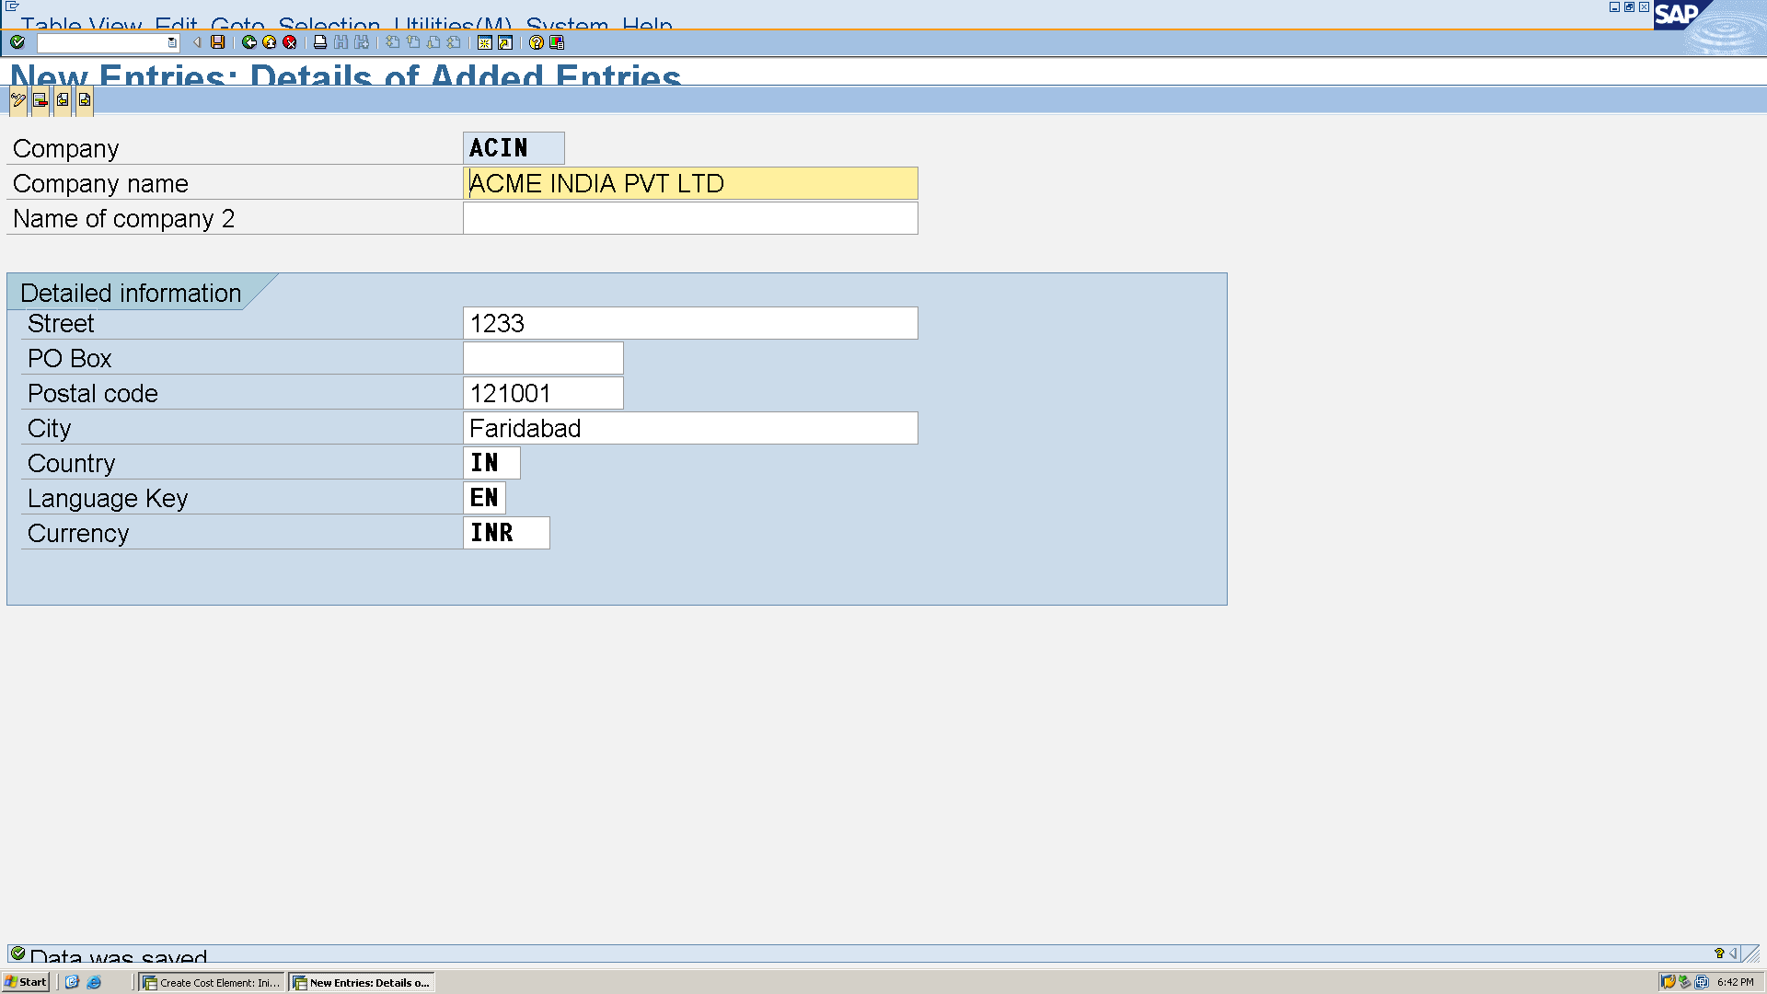

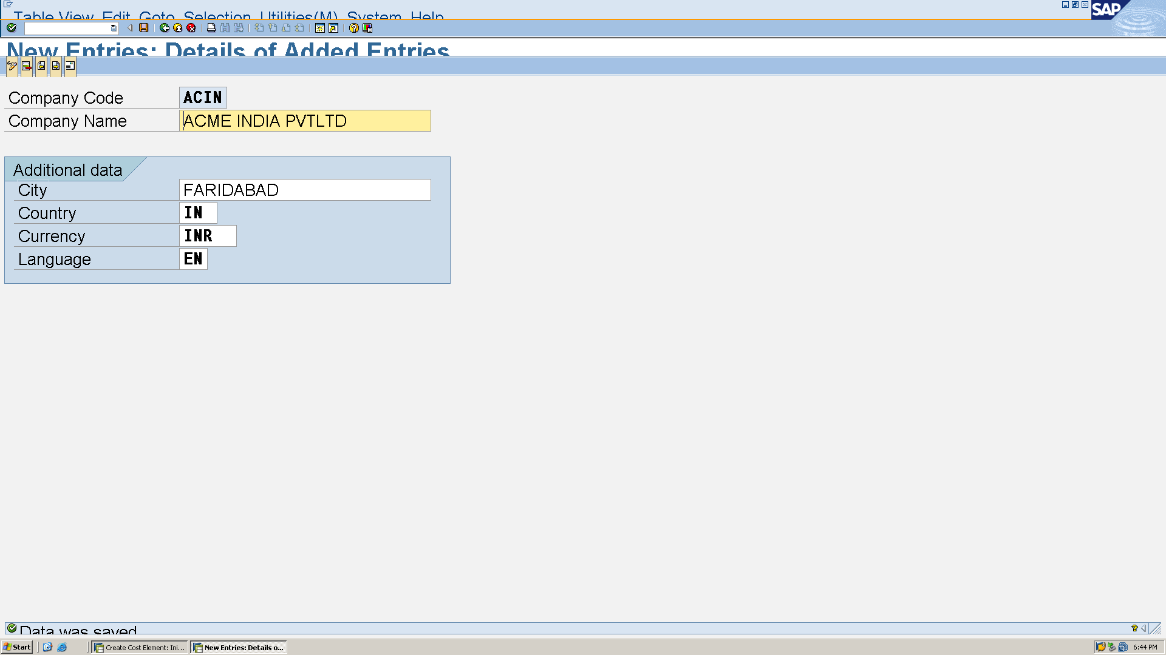

Assign company code in: **SPRO → Assignment → Financial Accounting → Assign Company Code to Company.**

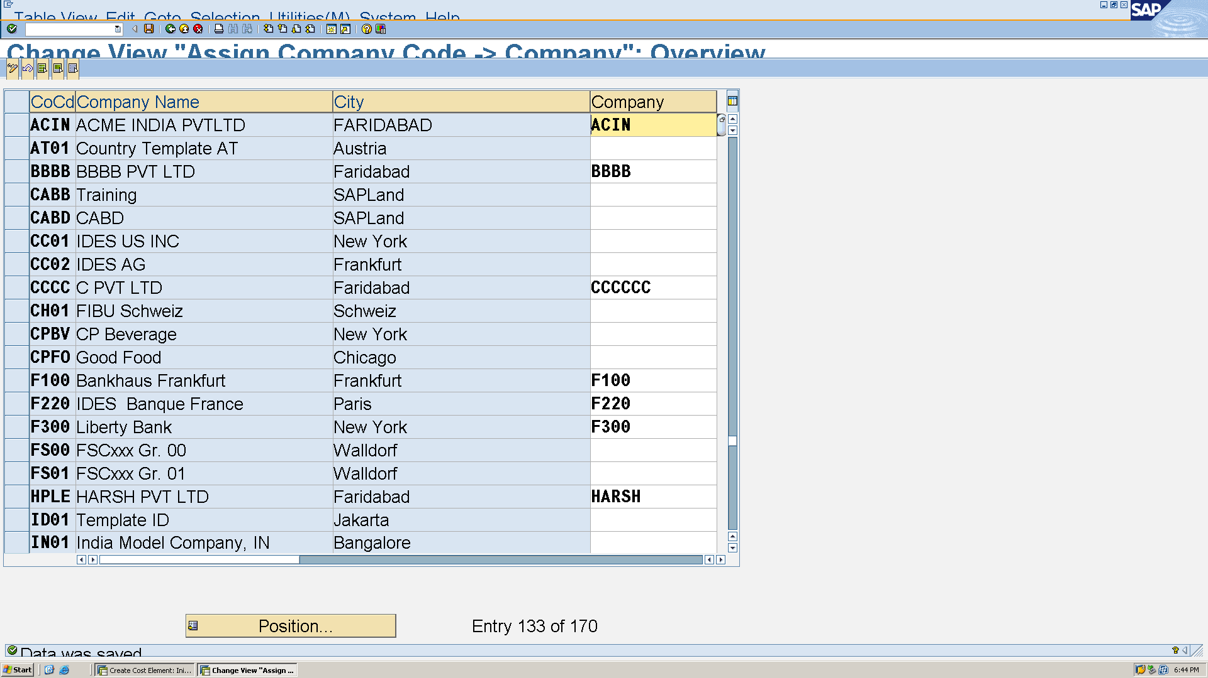

**SPRO → SAP Reference IMG → Financial Accounting → Financial Accounting Global Settings → Fiscal Year → Maintain Fiscal Year Variant**

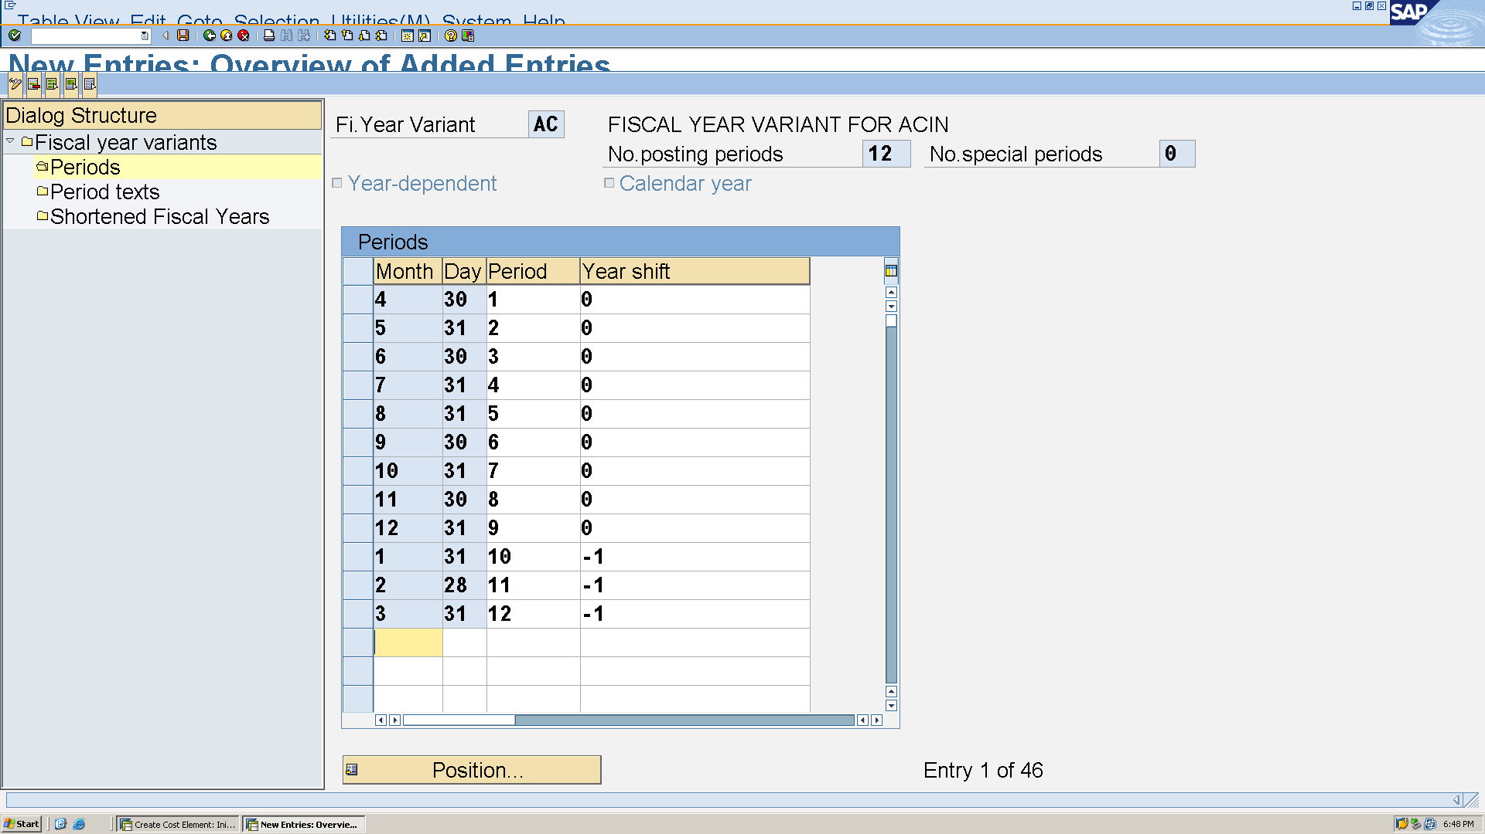

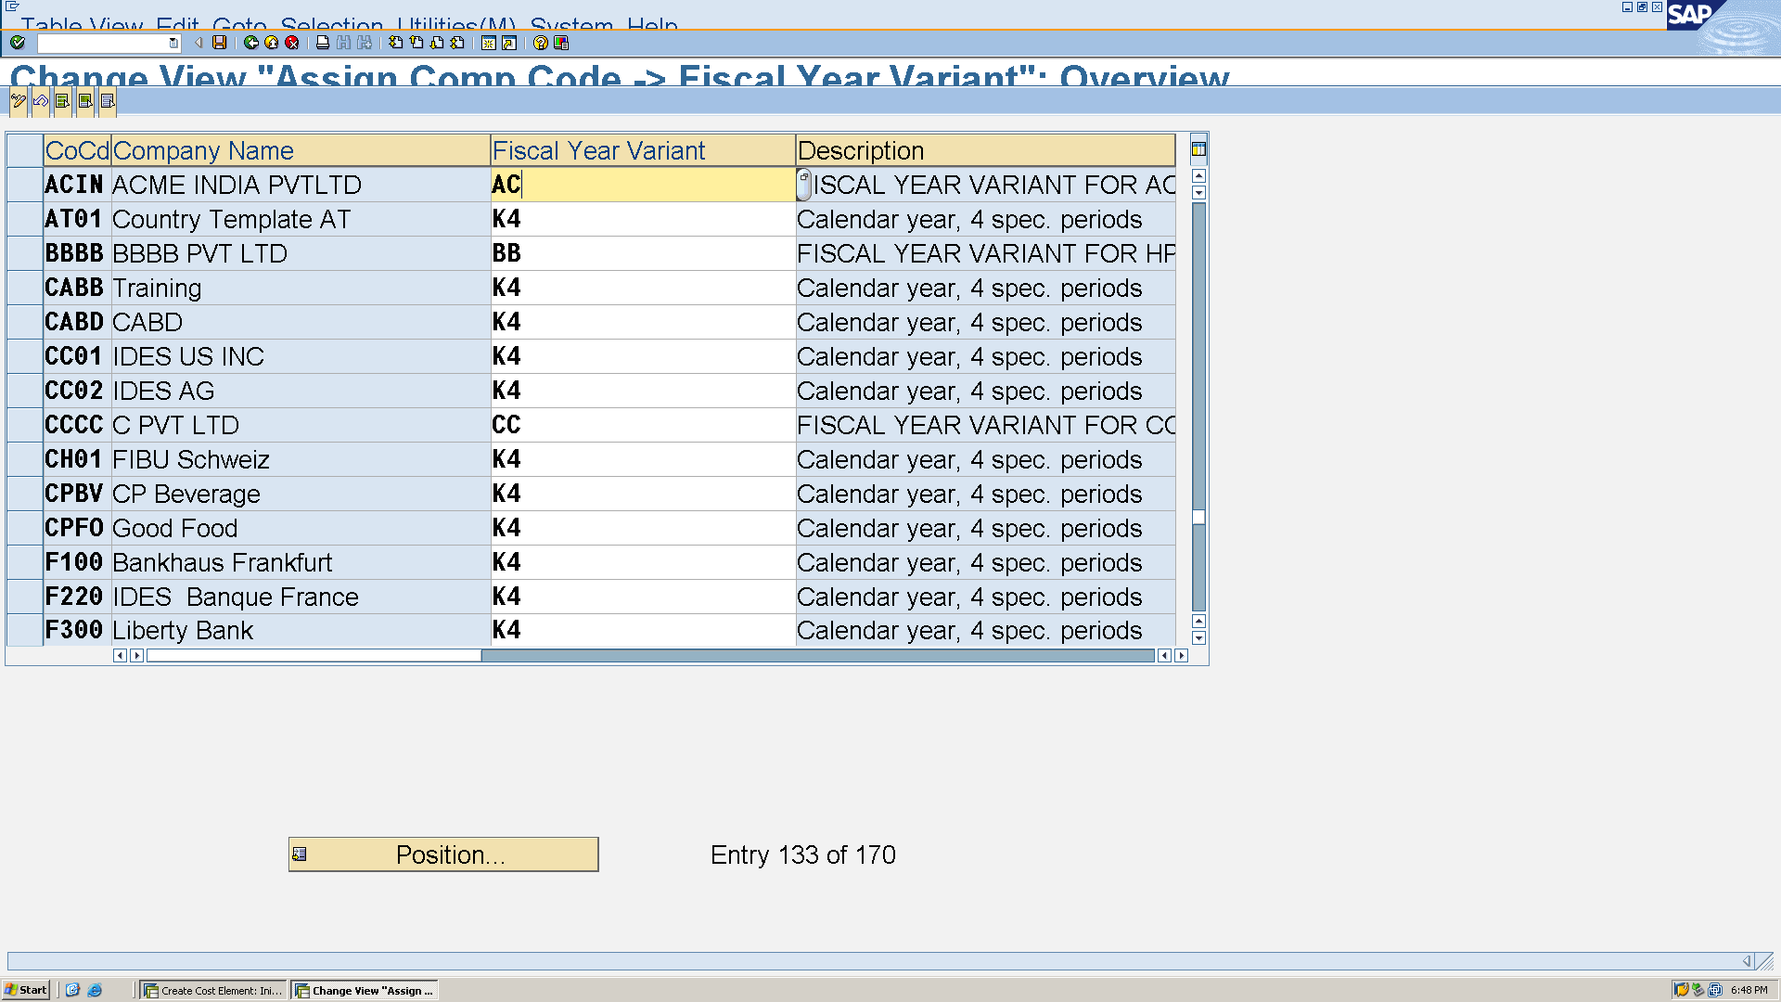

**SPRO → SAP Reference IMG → Financial Accounting → Financial Accounting Global Settings → Document → Posting Periods → Define Variants for Open Posting Periods**

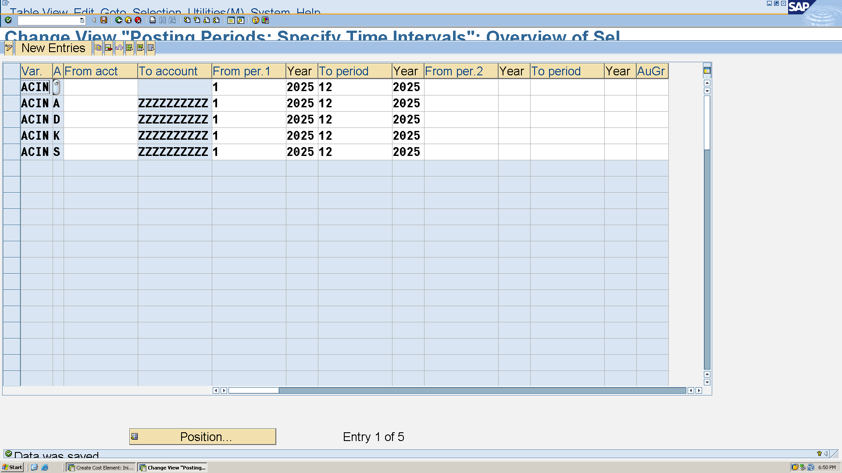

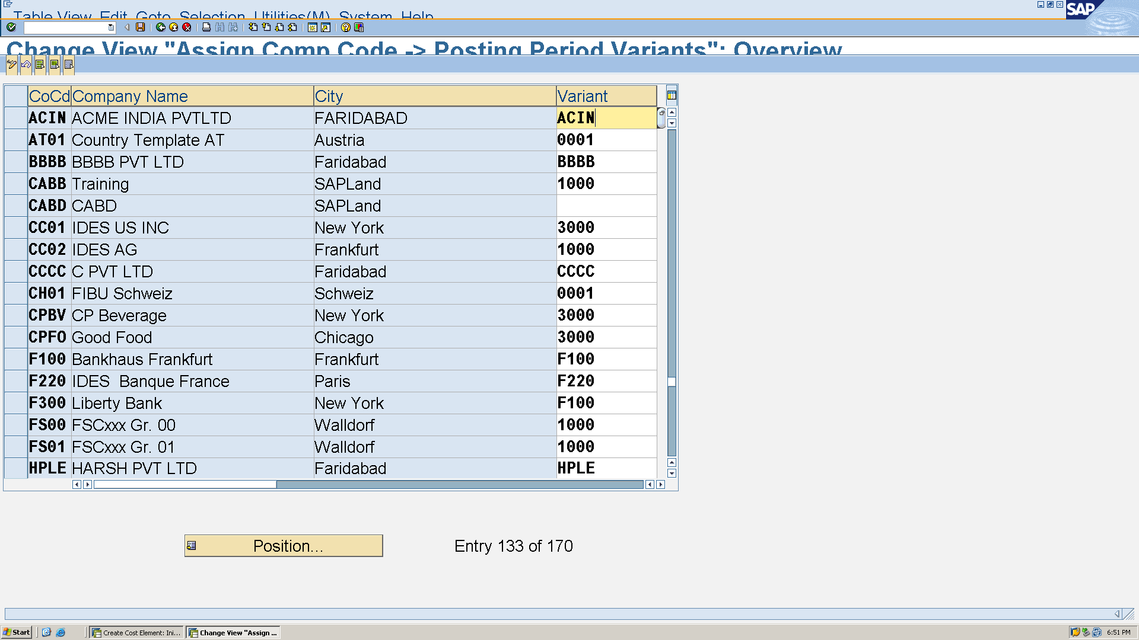

**Financial Accounting → Financial Accounting Global Settings → Document → Document Types → Define Document Types**

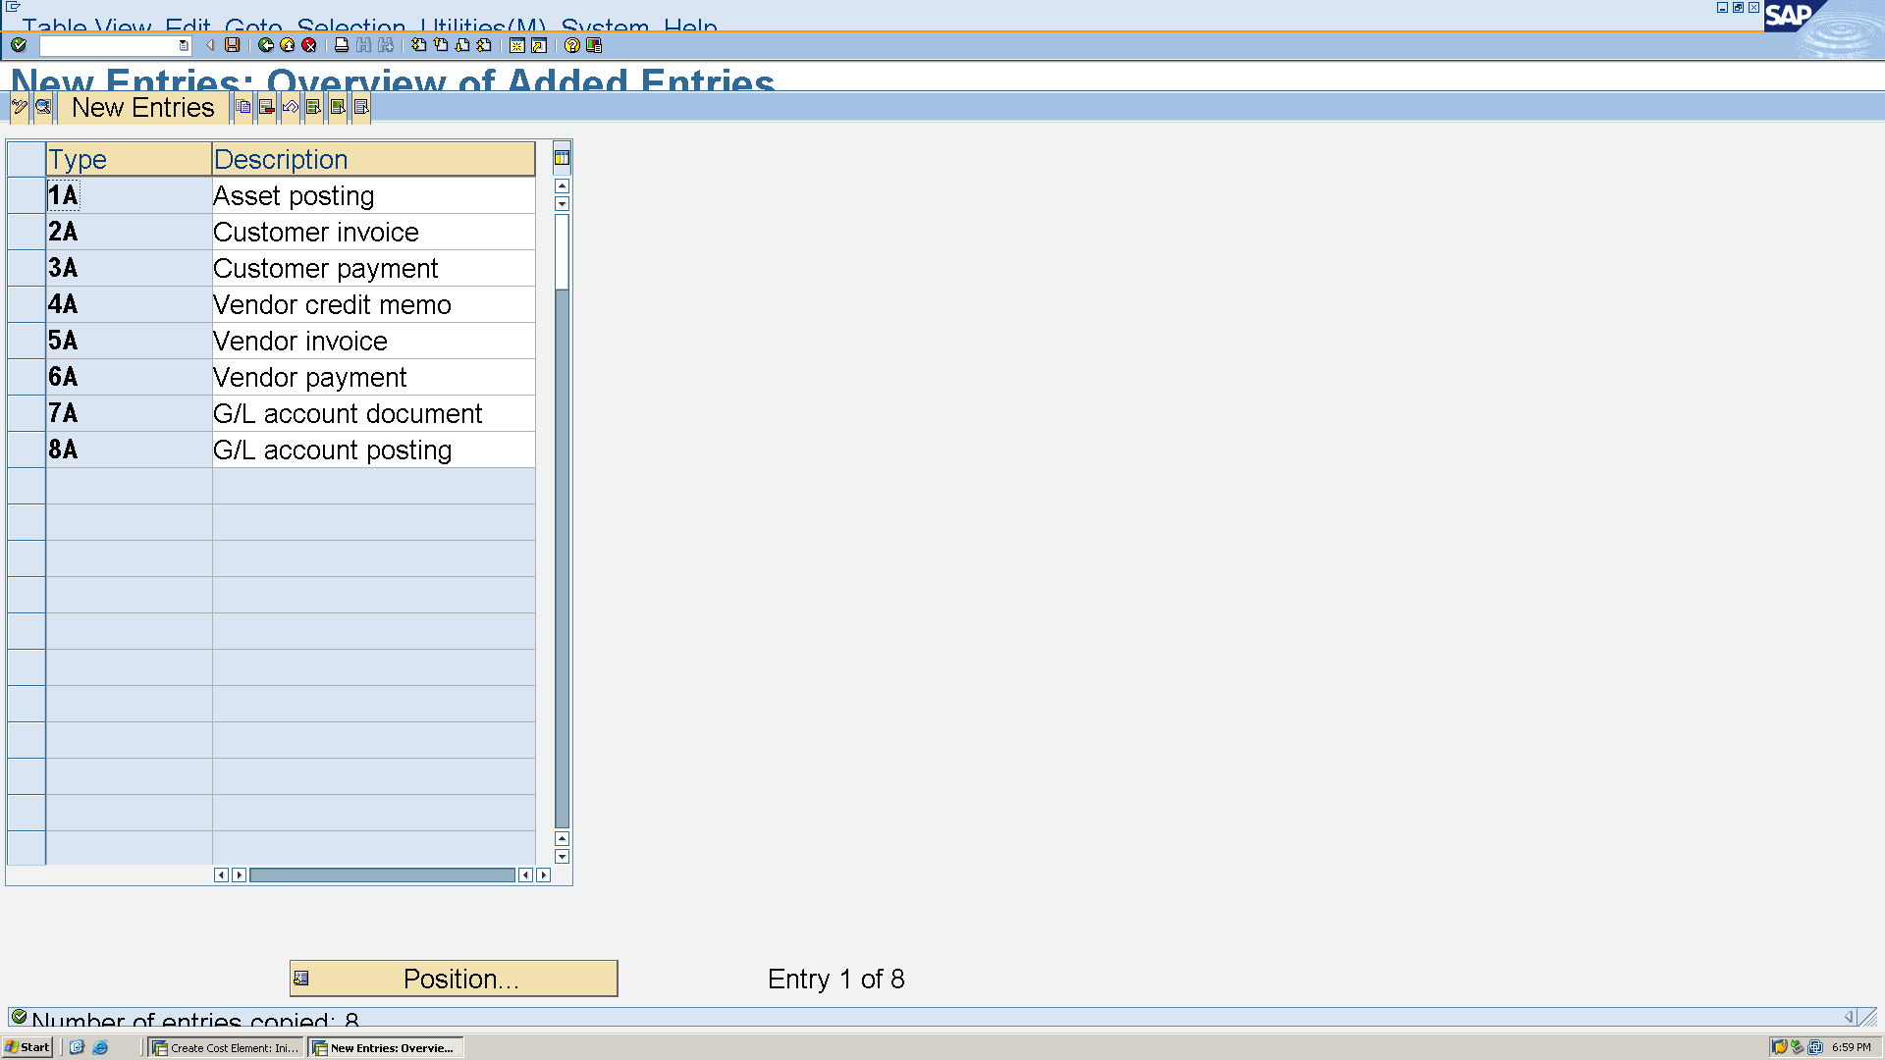

**SPRO → SAP Reference IMG → Financial Accounting → Financial Accounting Global Settings → Document → Line Item → Controls → Define Field Status Variants**

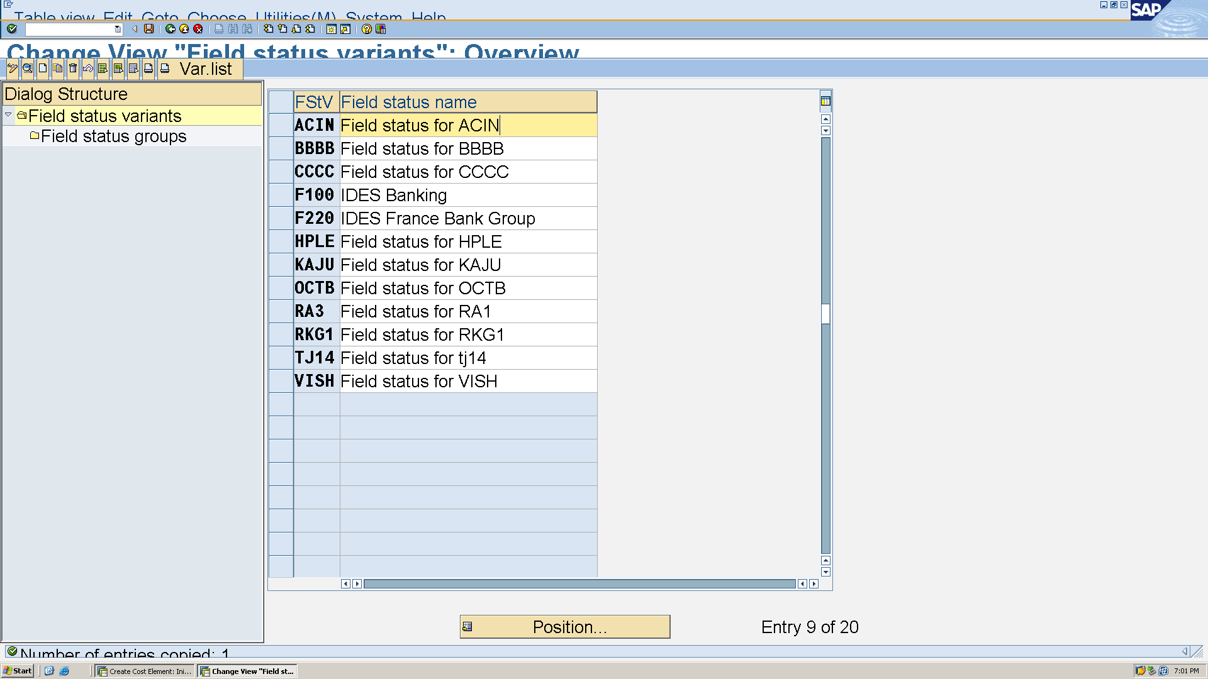

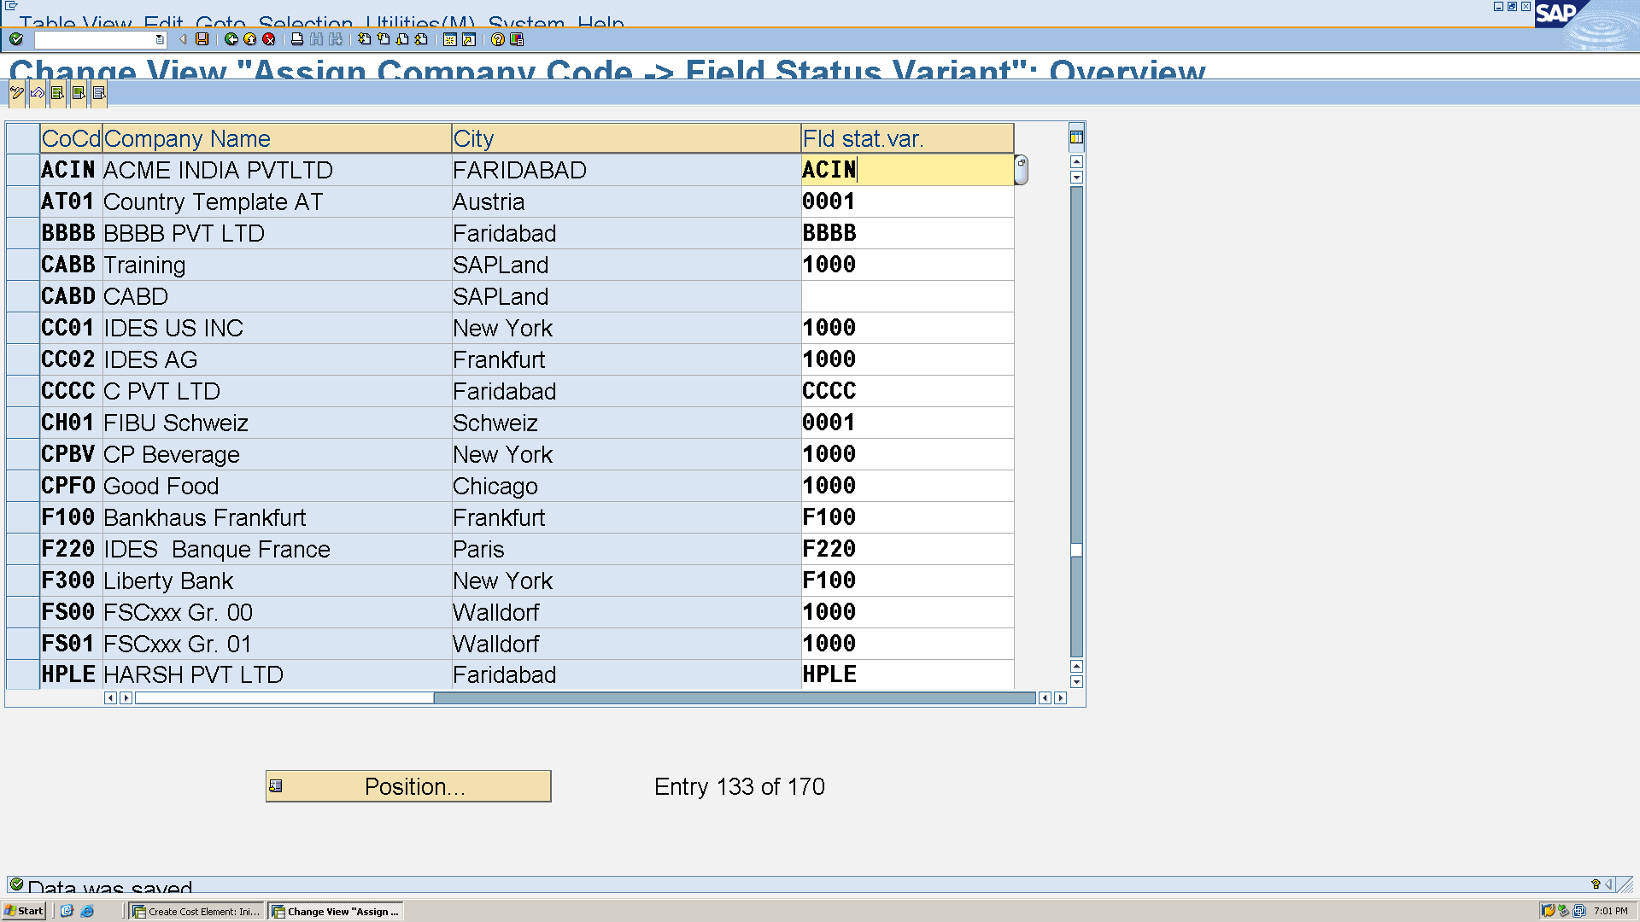

SPRO → SAP Reference IMG → Financial Accounting → General Ledger Accounting → G/L Accounts → Master Data → Preparations → Edit Chart of Accounts List

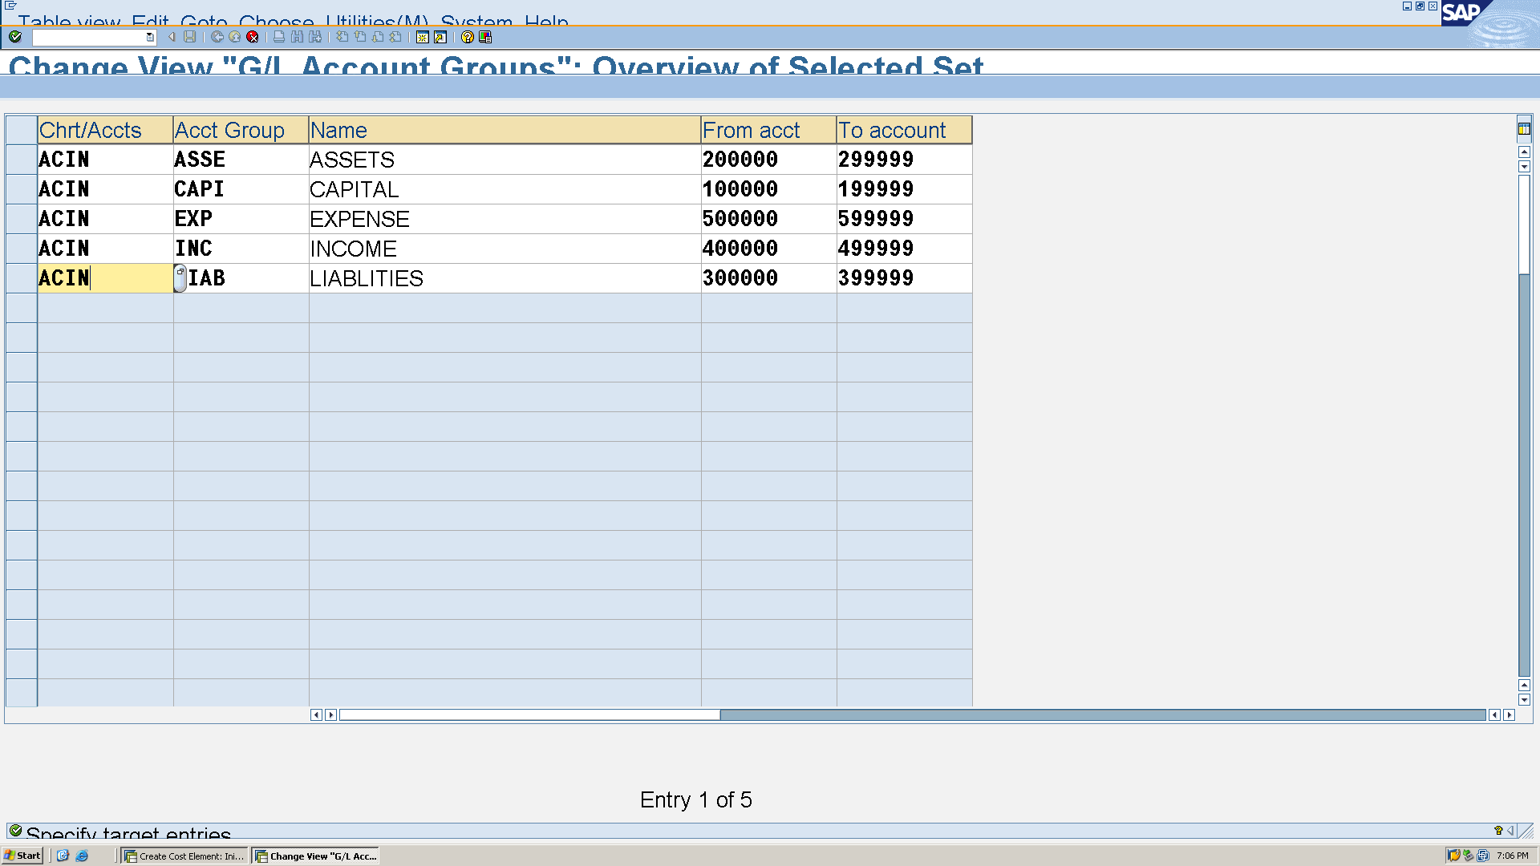

**b. GL Accounts**

**FS00** to create GL accounts, specifying account groups and reconciliation accounts as needed.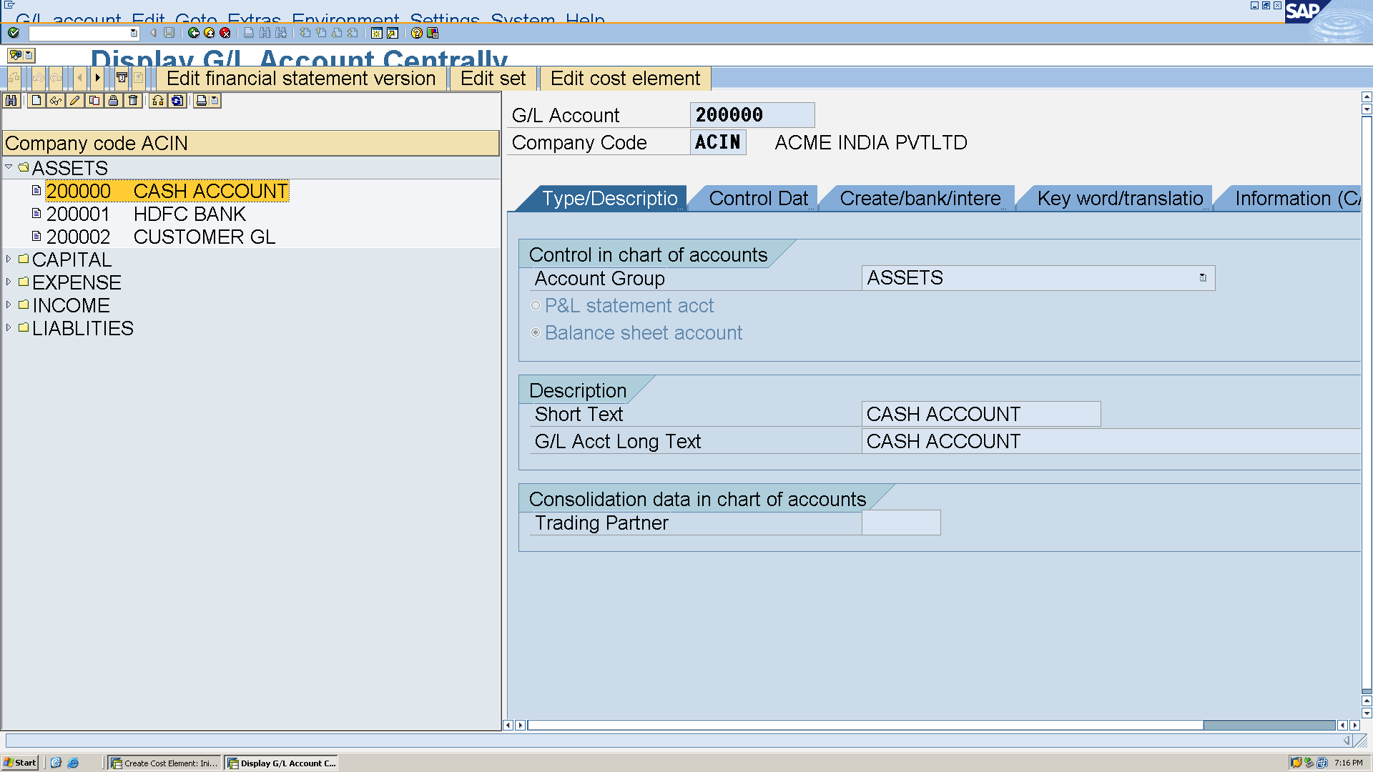

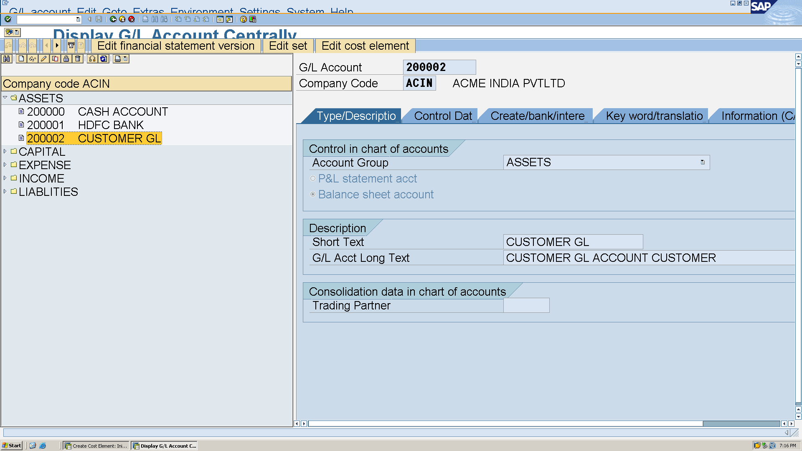

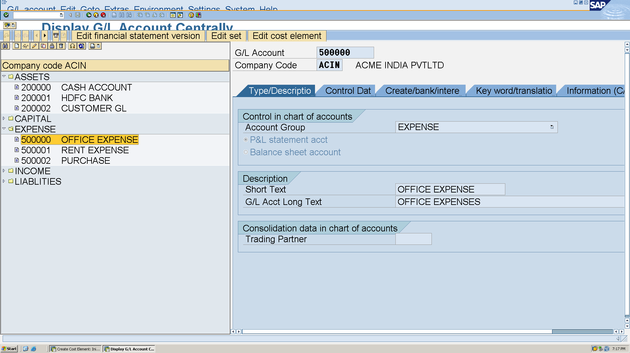

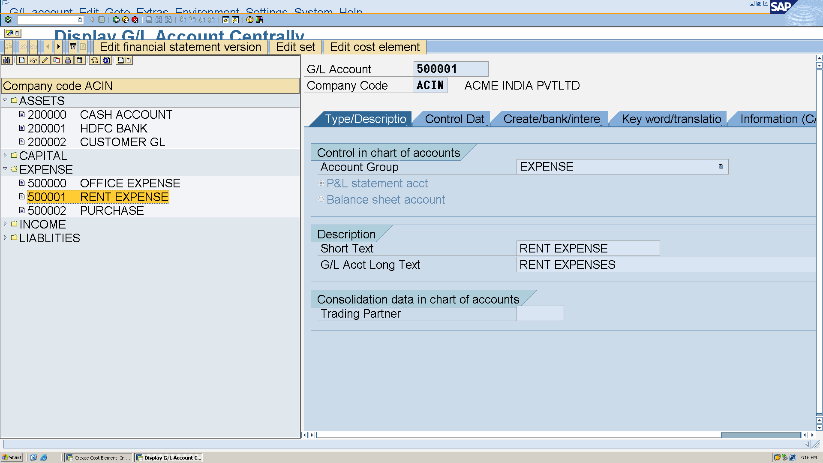

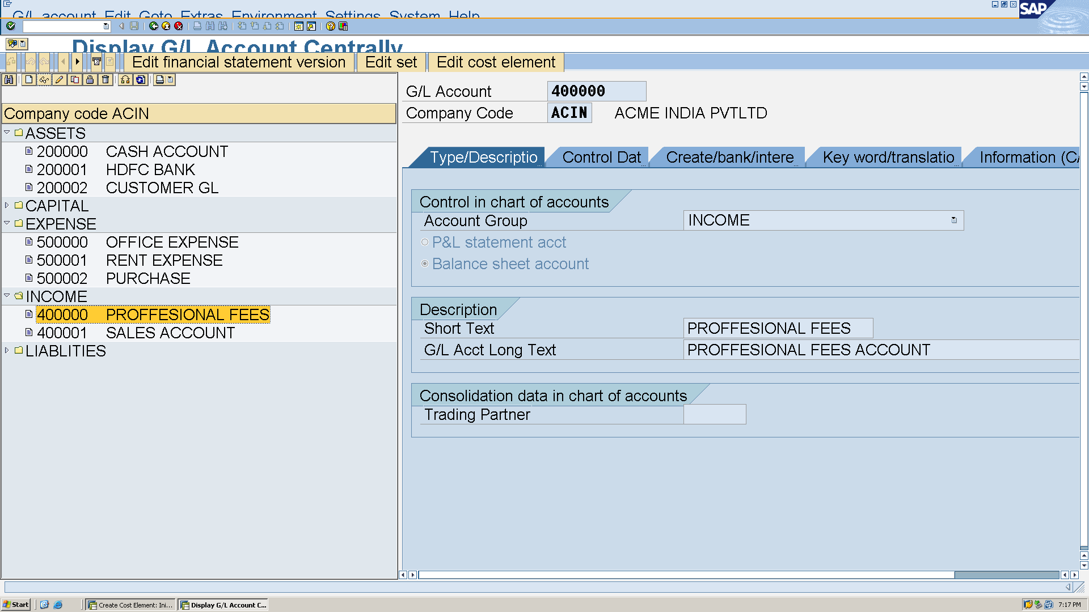

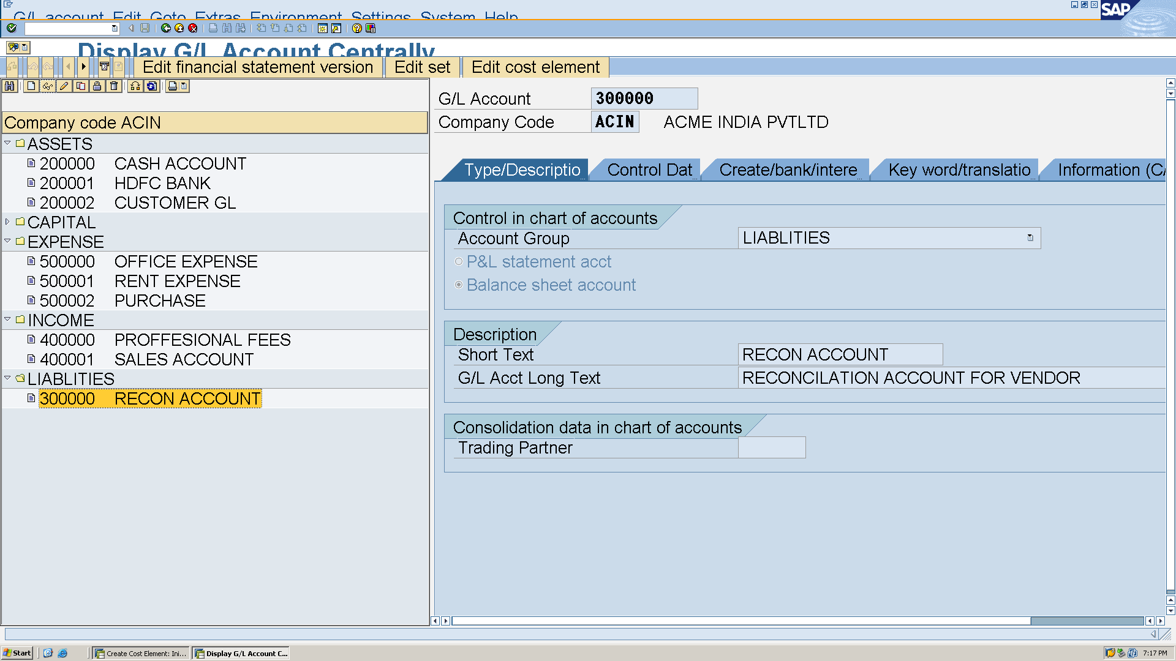

**c. customer Master**

Customer account group T-code **OBD2**

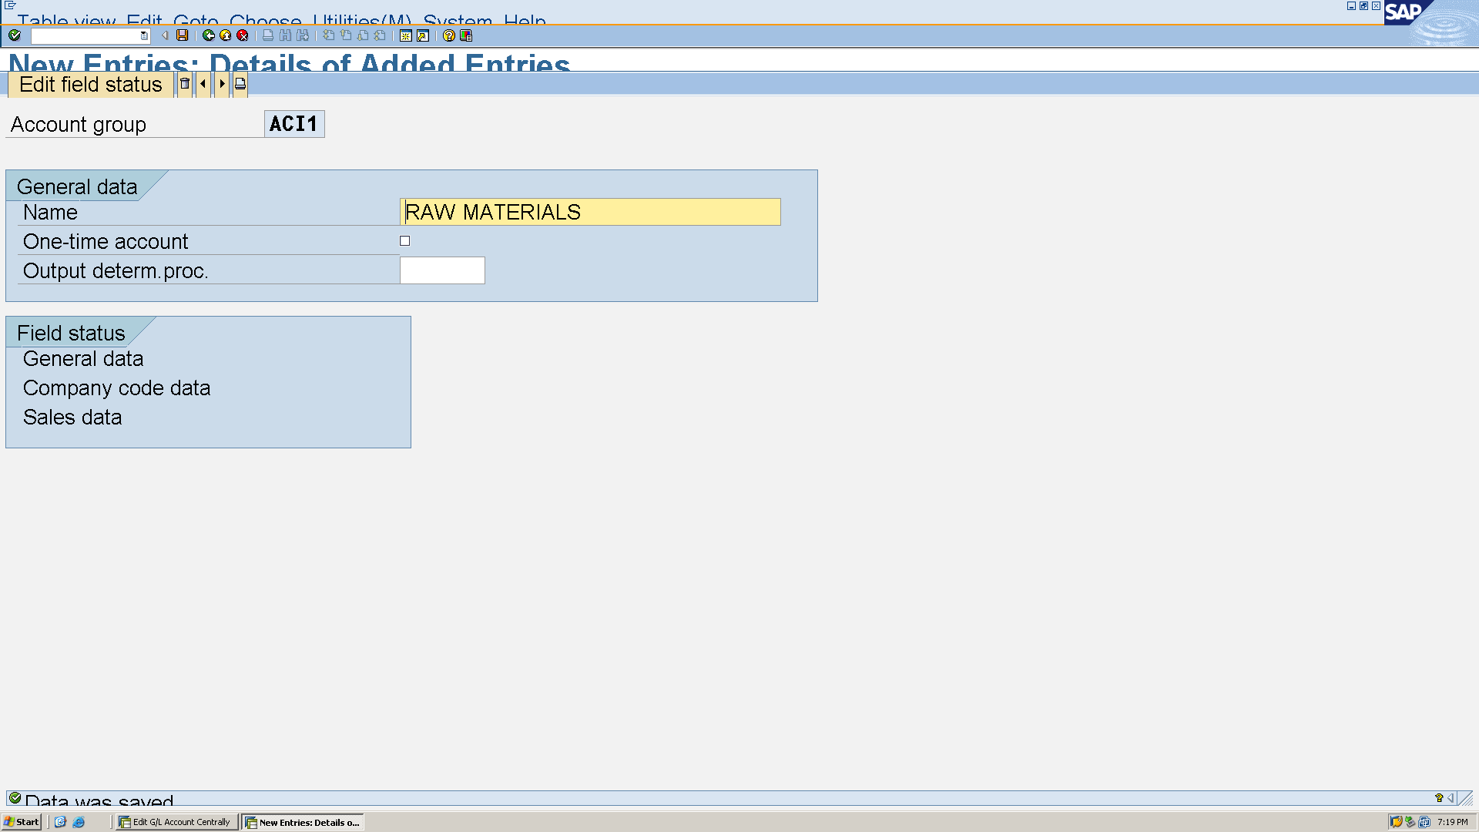

Customer number range T-code **XDN1**

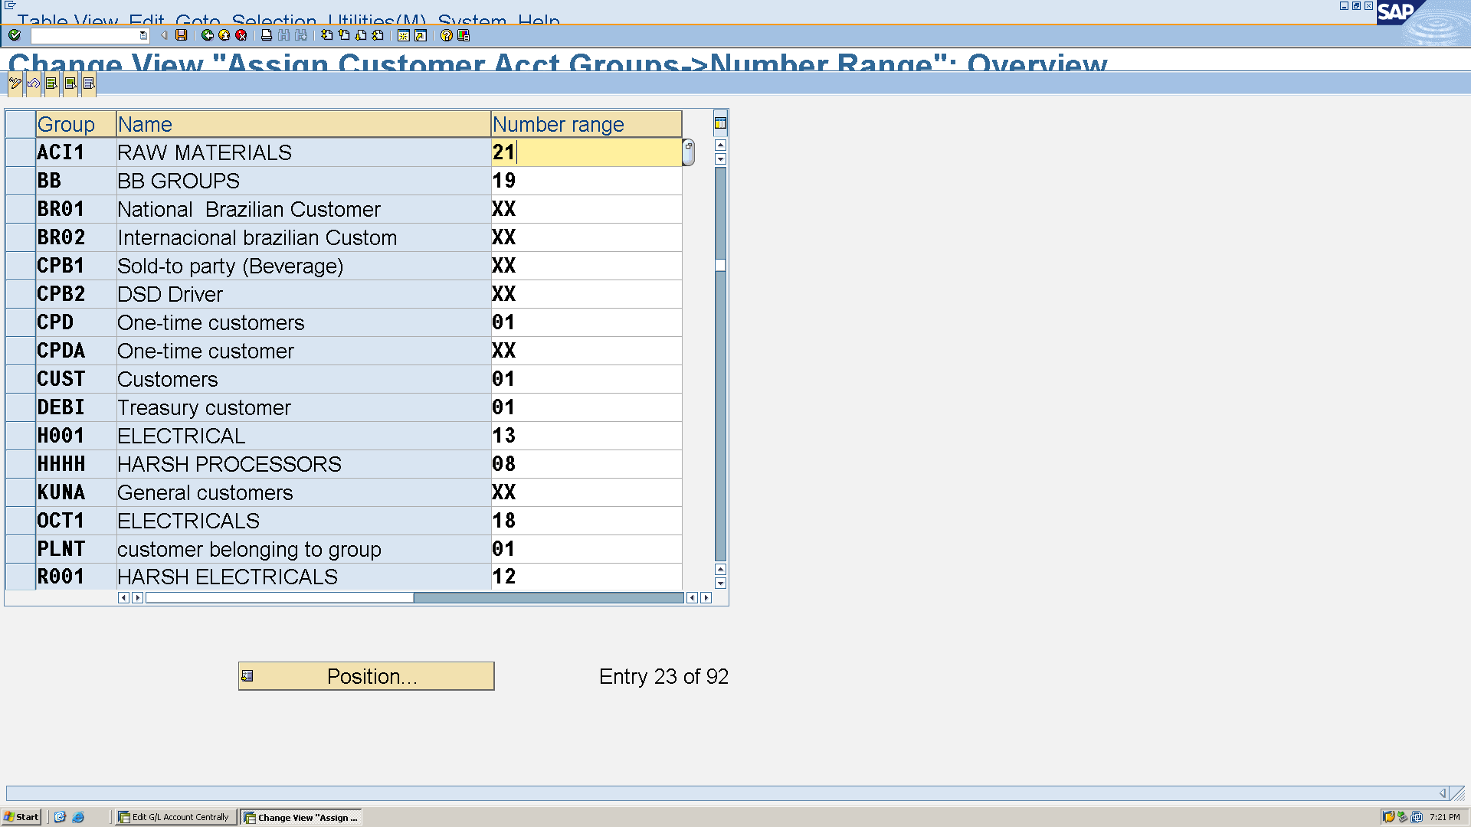

Customer No. range assign T-code **OBAR**

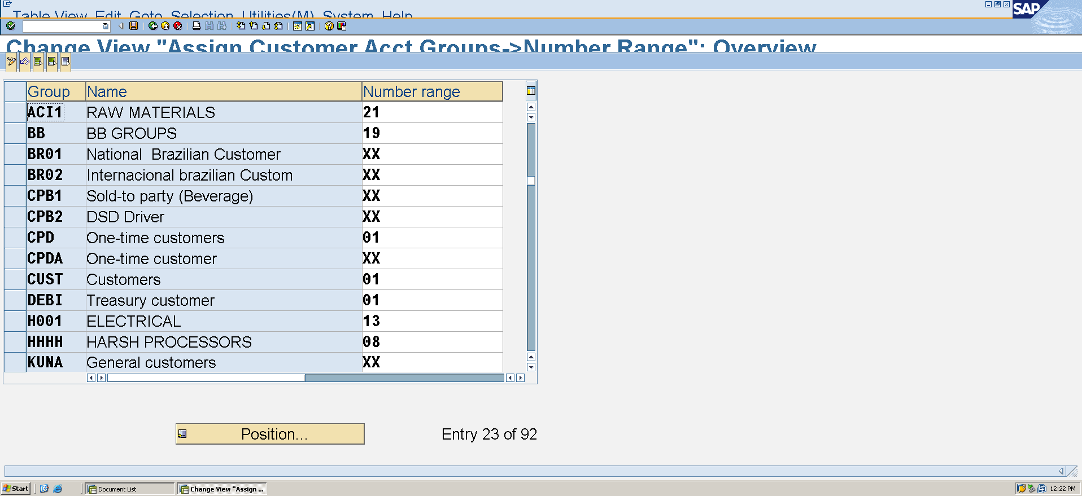

Creation of customer T-code **XD01**

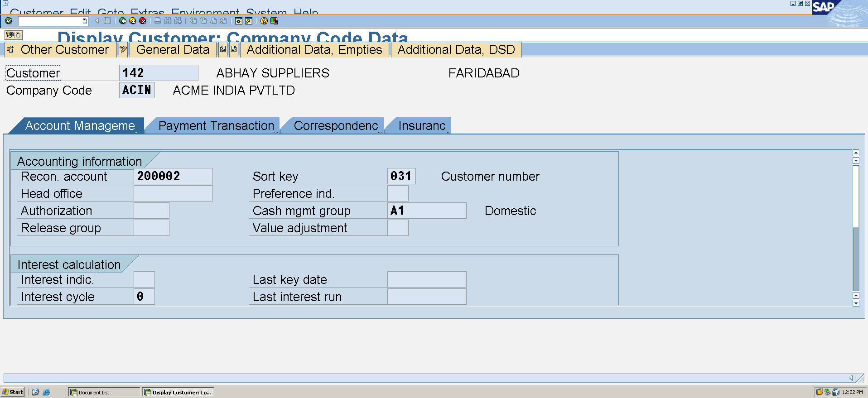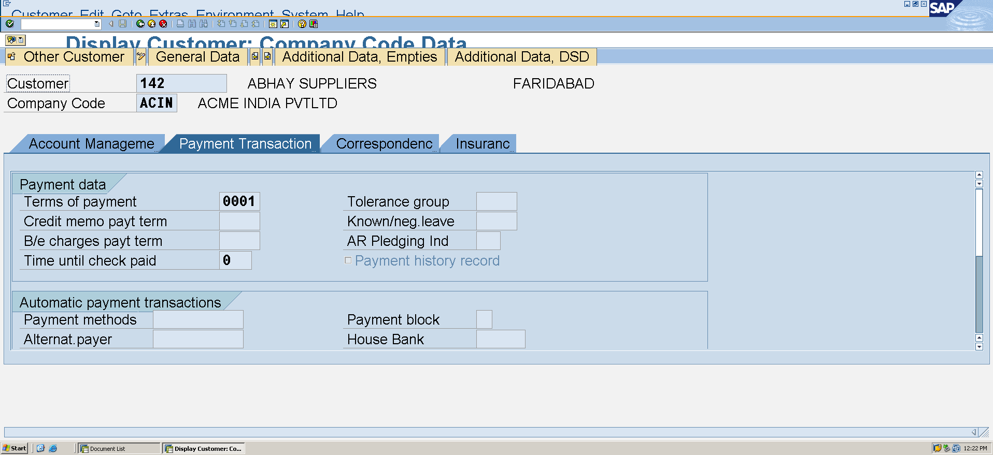

**D. Vendor Master**

vendor account group T-code **OBD3**

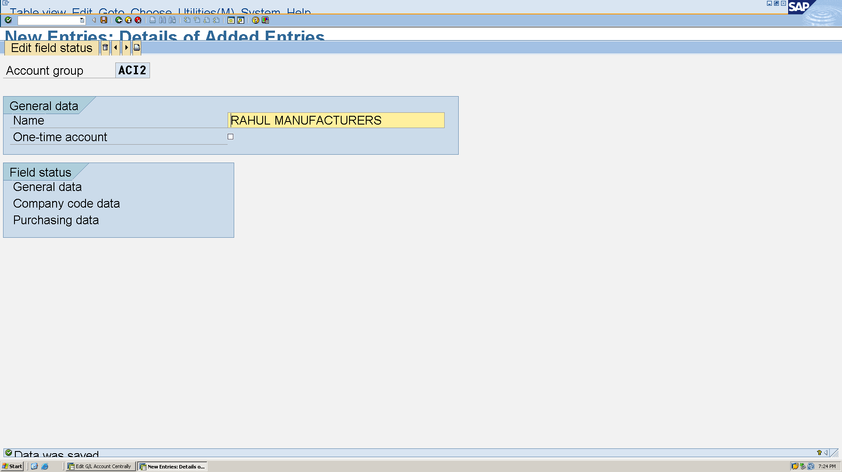

Vendor number range Tcode XKN1, OBAS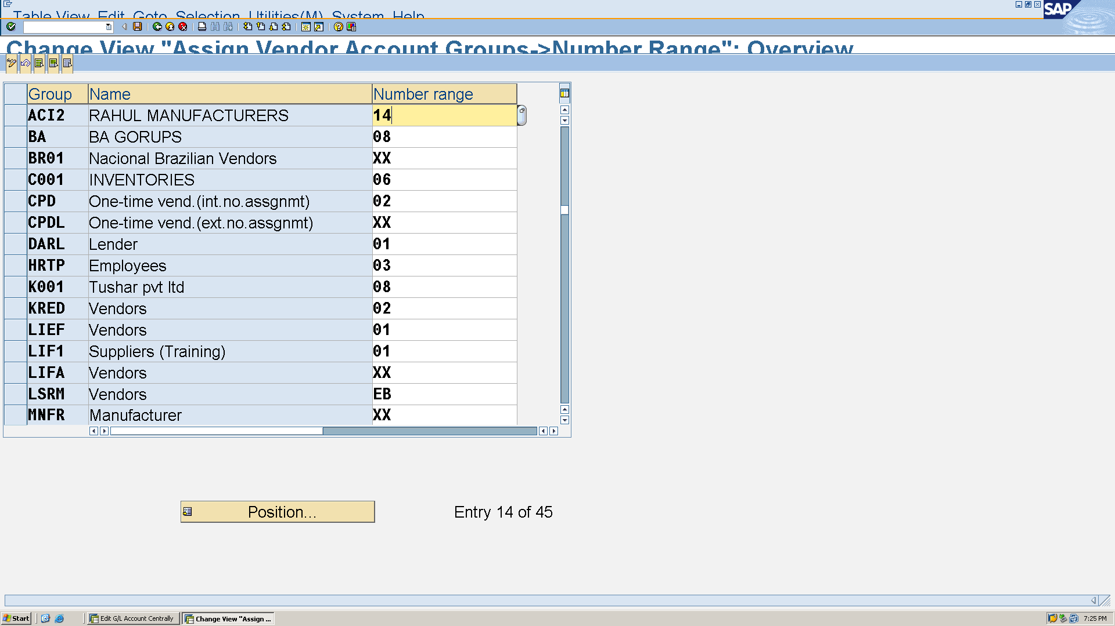

Creation of vendor T-code **XK01**

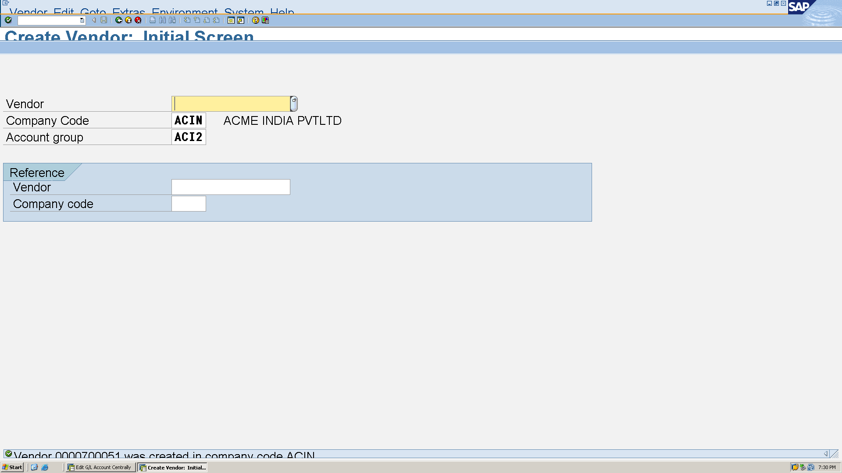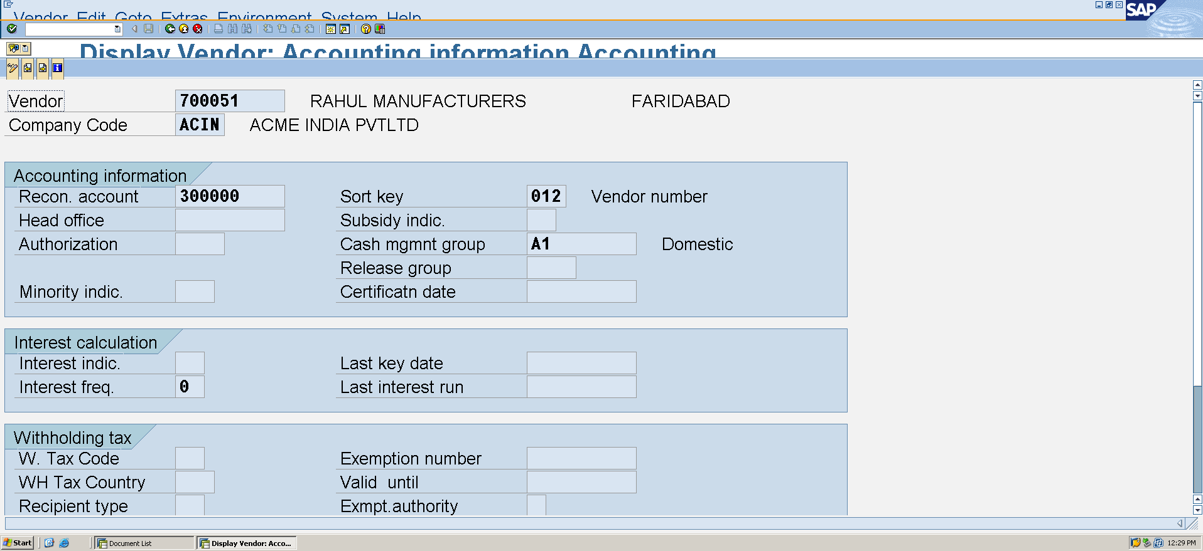

**2.2 Transaction Postings (for August 2025)**

a. Asset Acquisition

**Financial Accounting → Asset Accounting → Organizational Structures → Specify Chart of Depreciation, Company Code, and Business Areas**

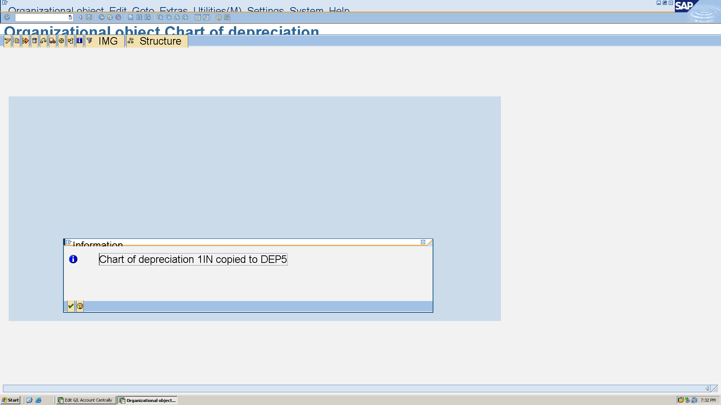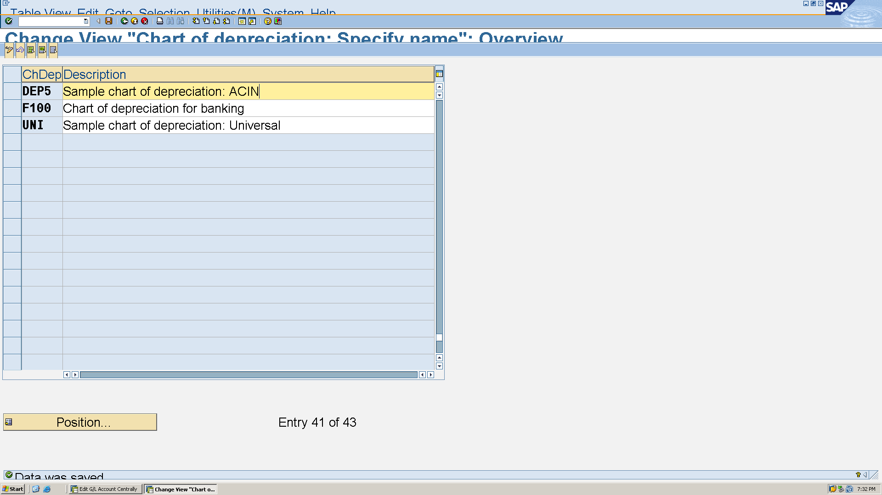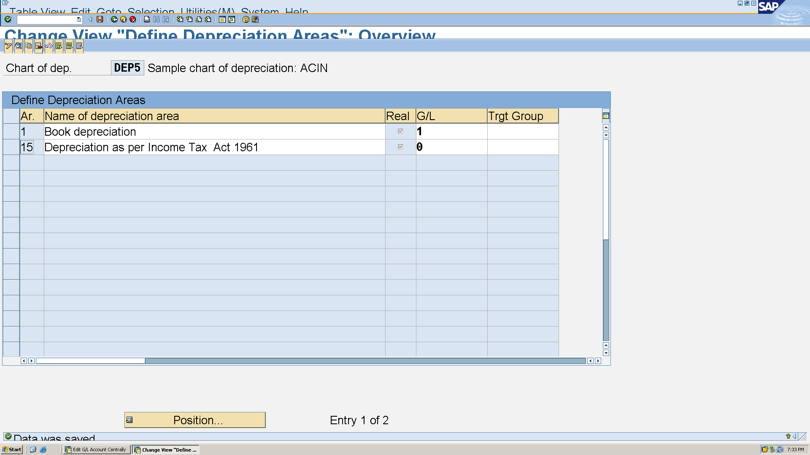

GST Configuration to integrate

**SPRO → SAP Reference IMG → Financial Accounting → Financial Accounting Global Settings → Tax on Sales/Purchases → Basic Settings → Check Calculation Procedure**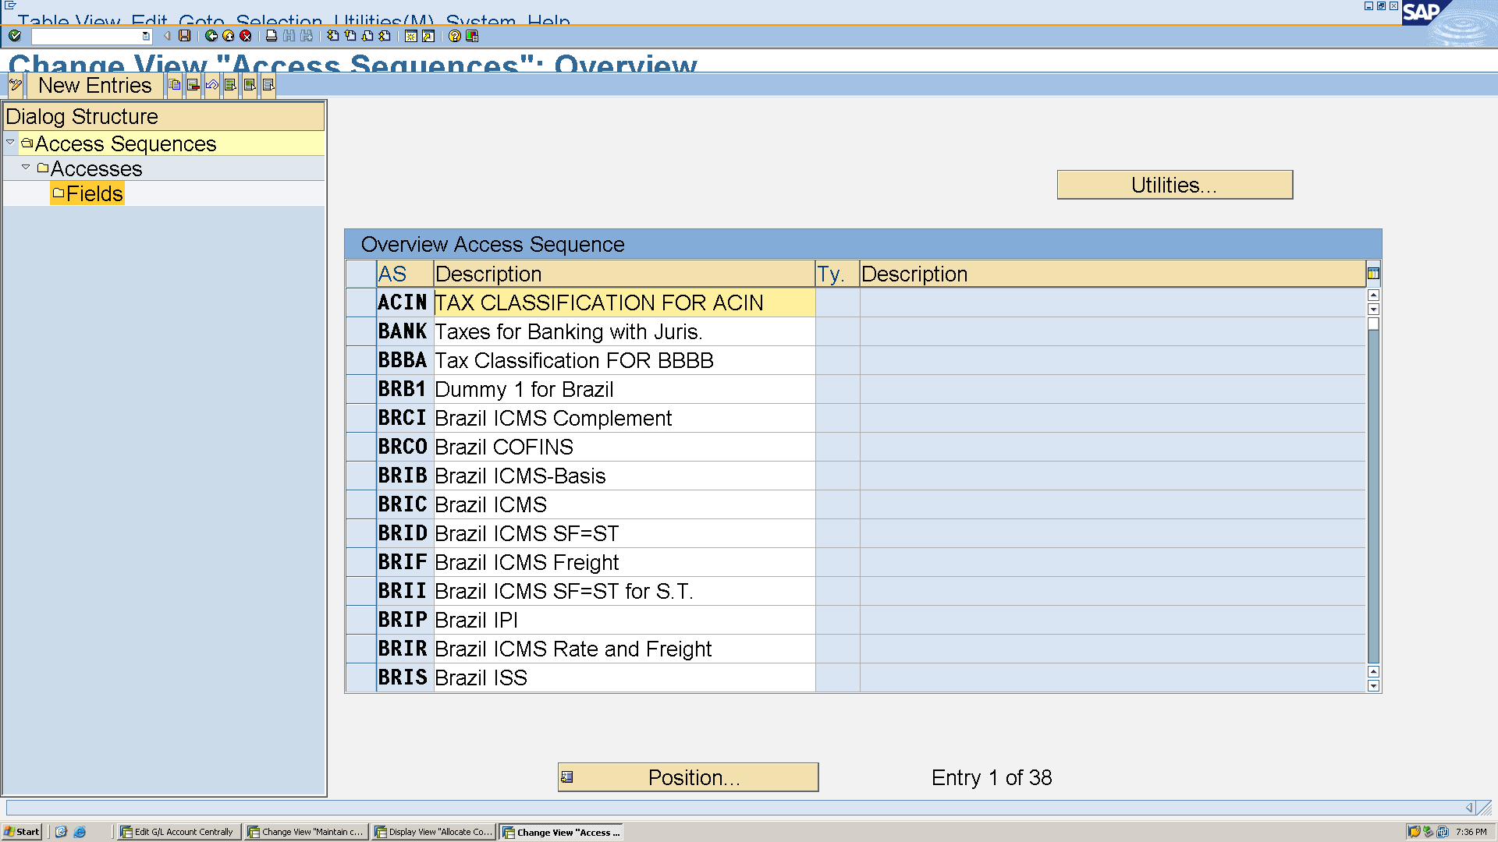

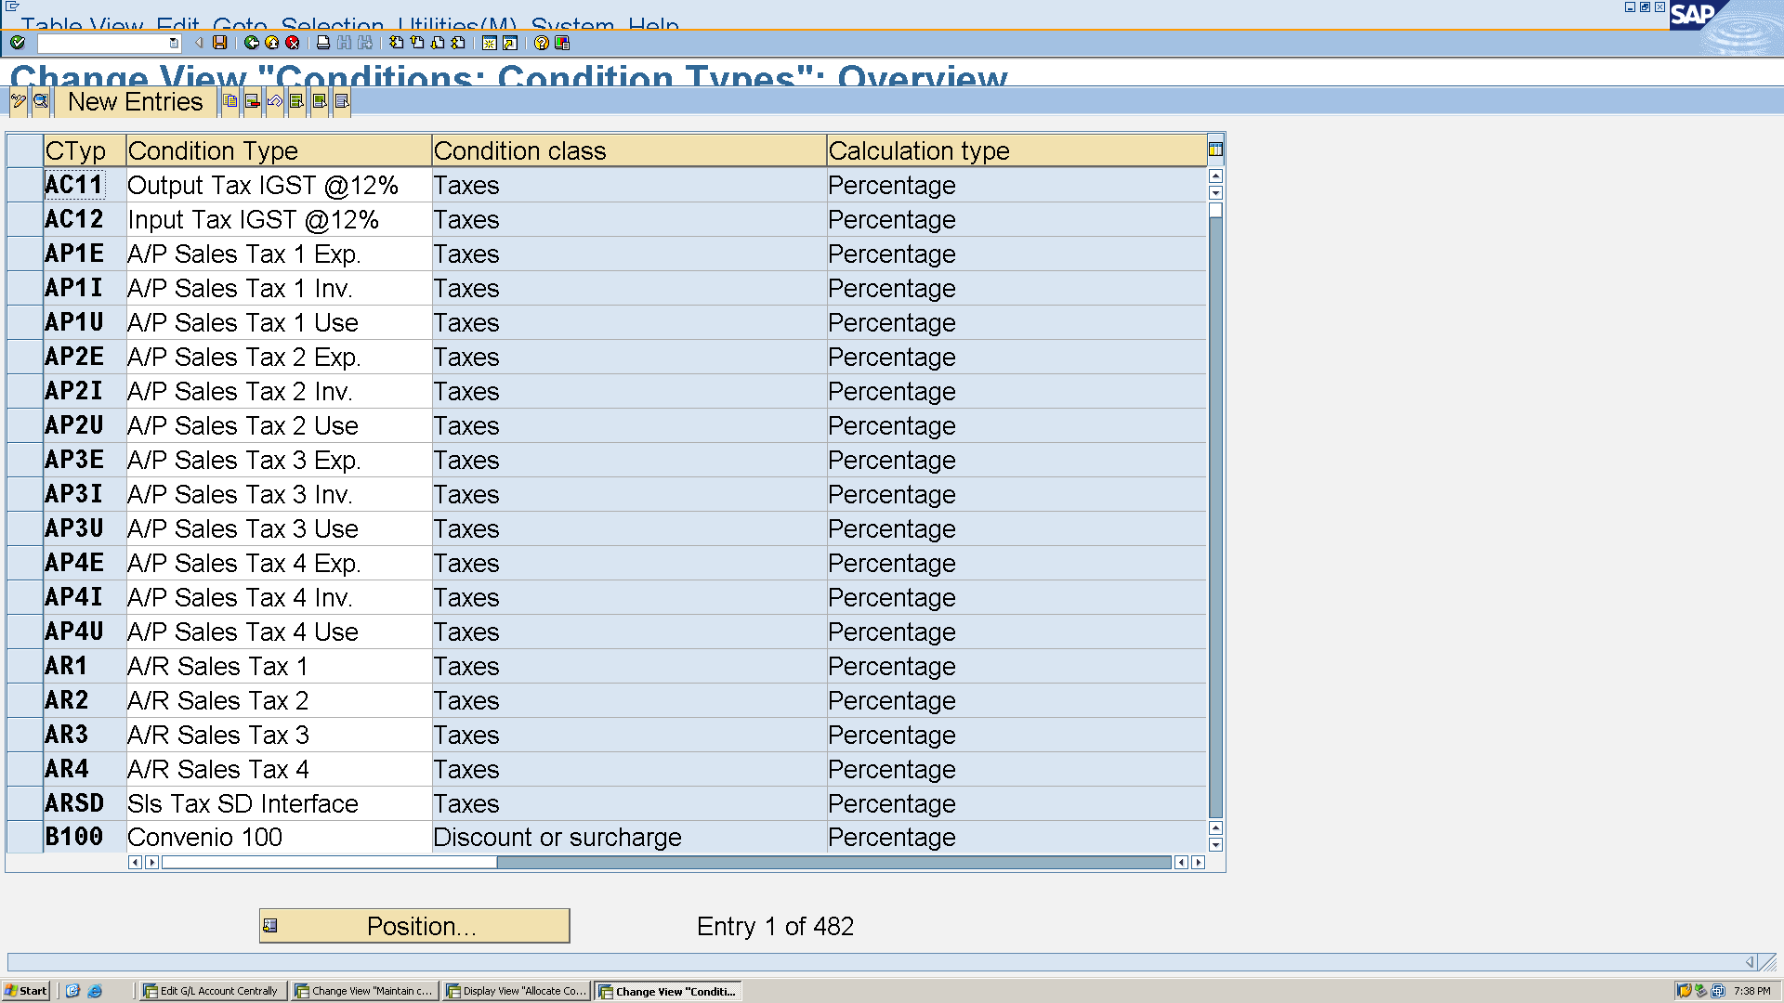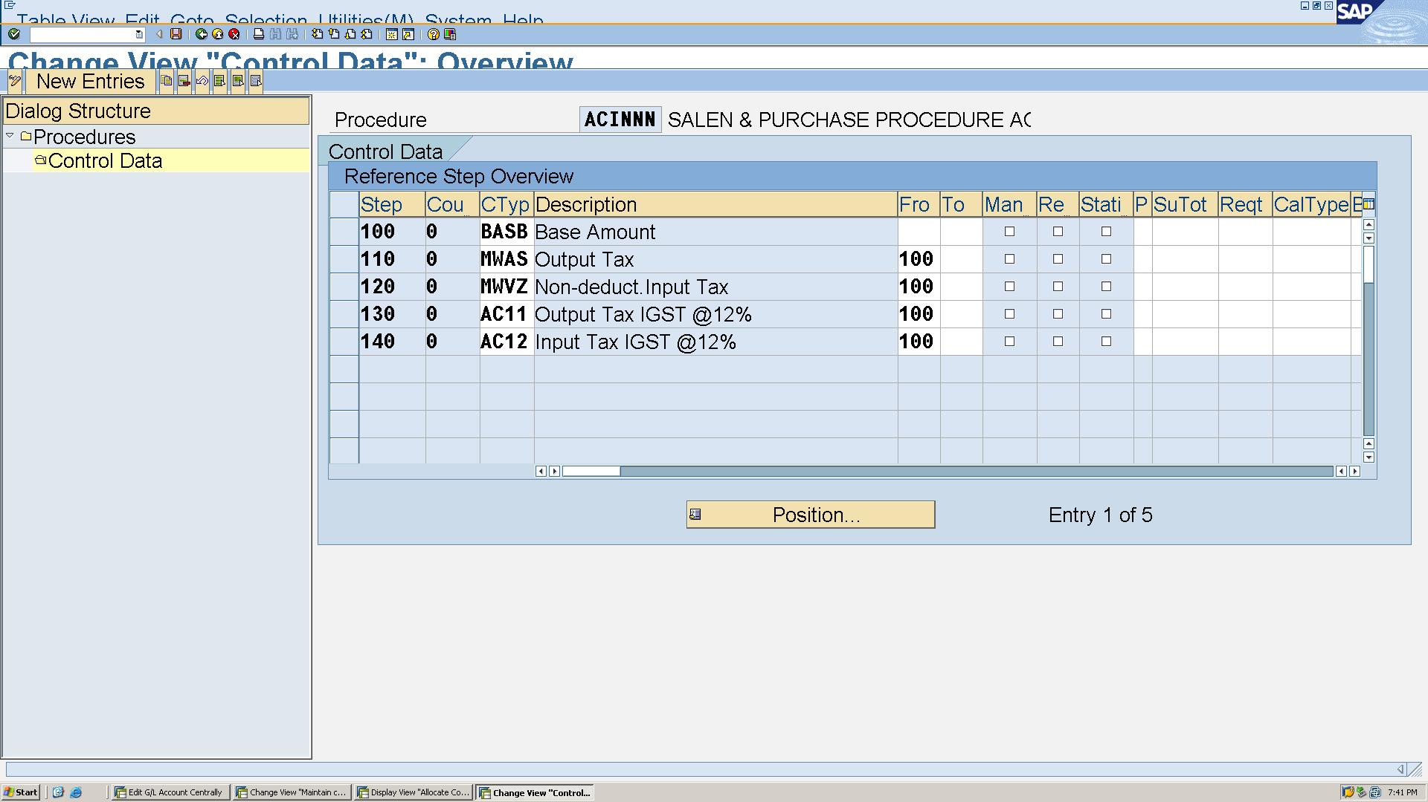To maintain tax code T-code **FTXP**

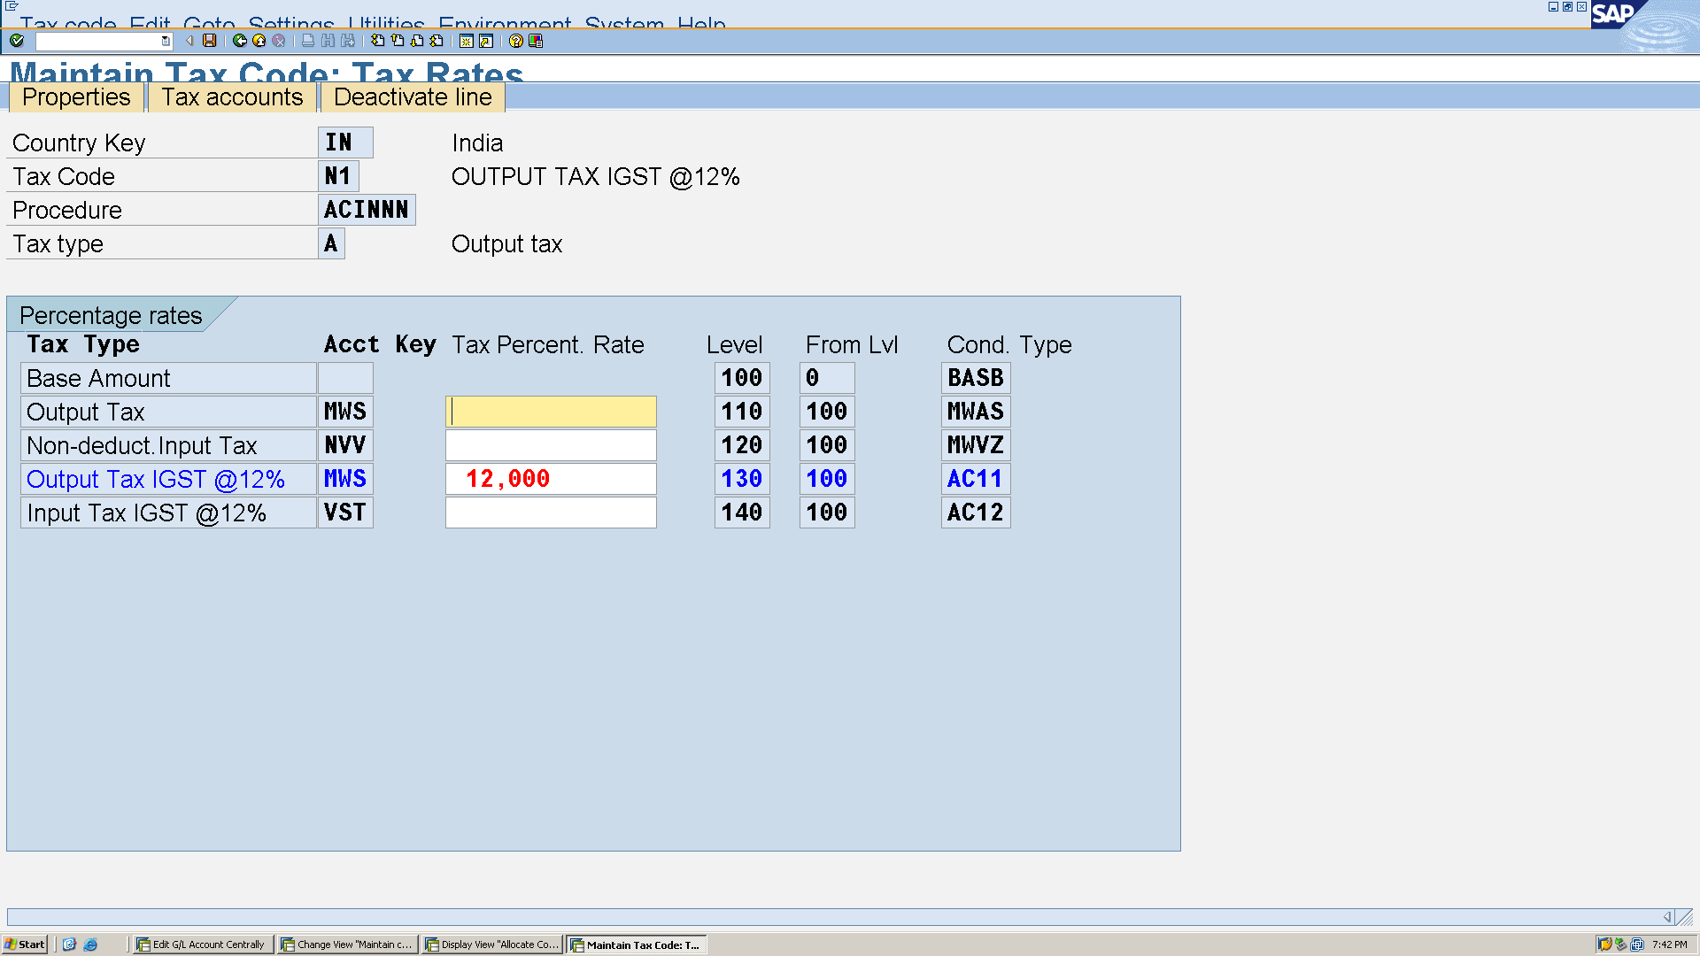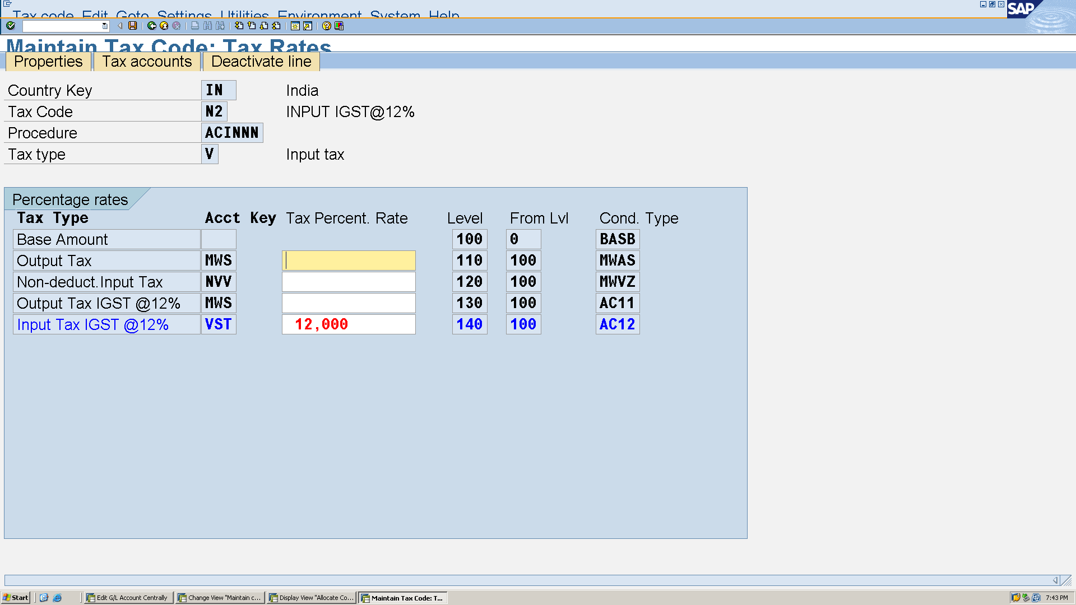Now, to integrate T-code **OBCL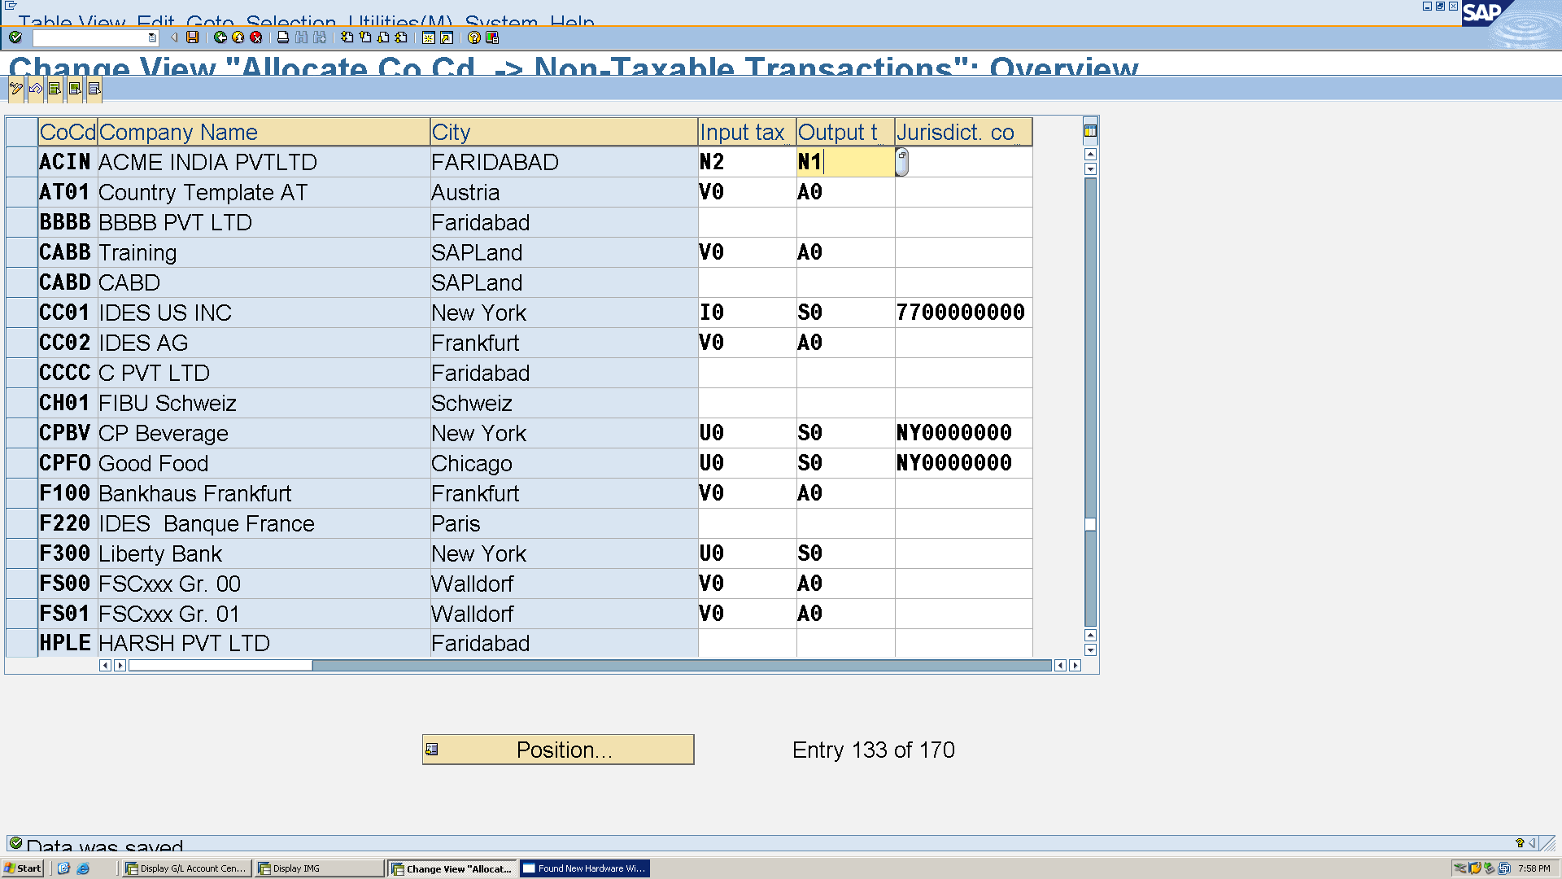 SPRO → SAP Reference IMG → Financial Accounting → Financial Accounting Global Settings → Tax on Sales/Purchases → Basic Settings → Check Calculation Procedure 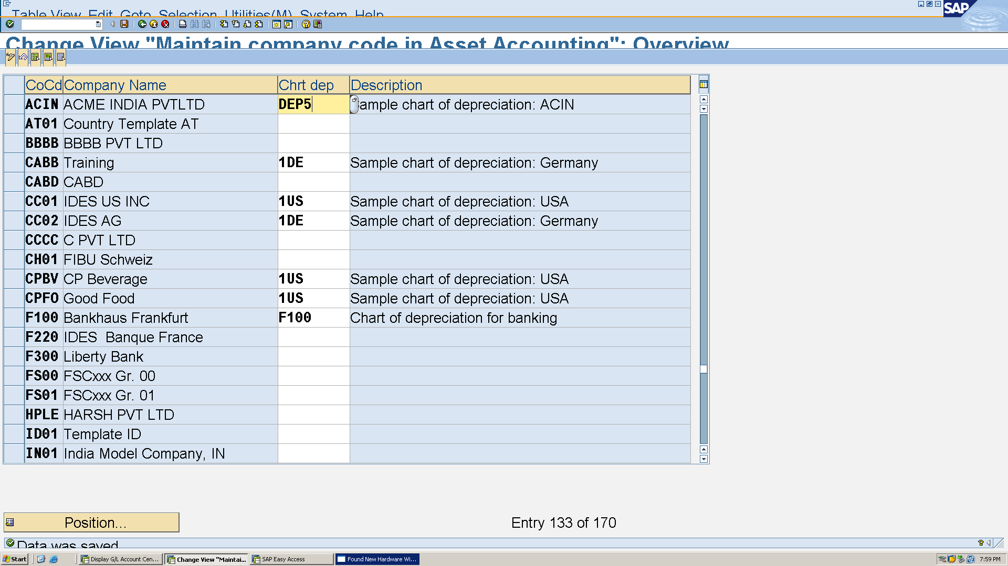 Financial Accounting → Asset Accounting → Master Data → Define Asset Classes** 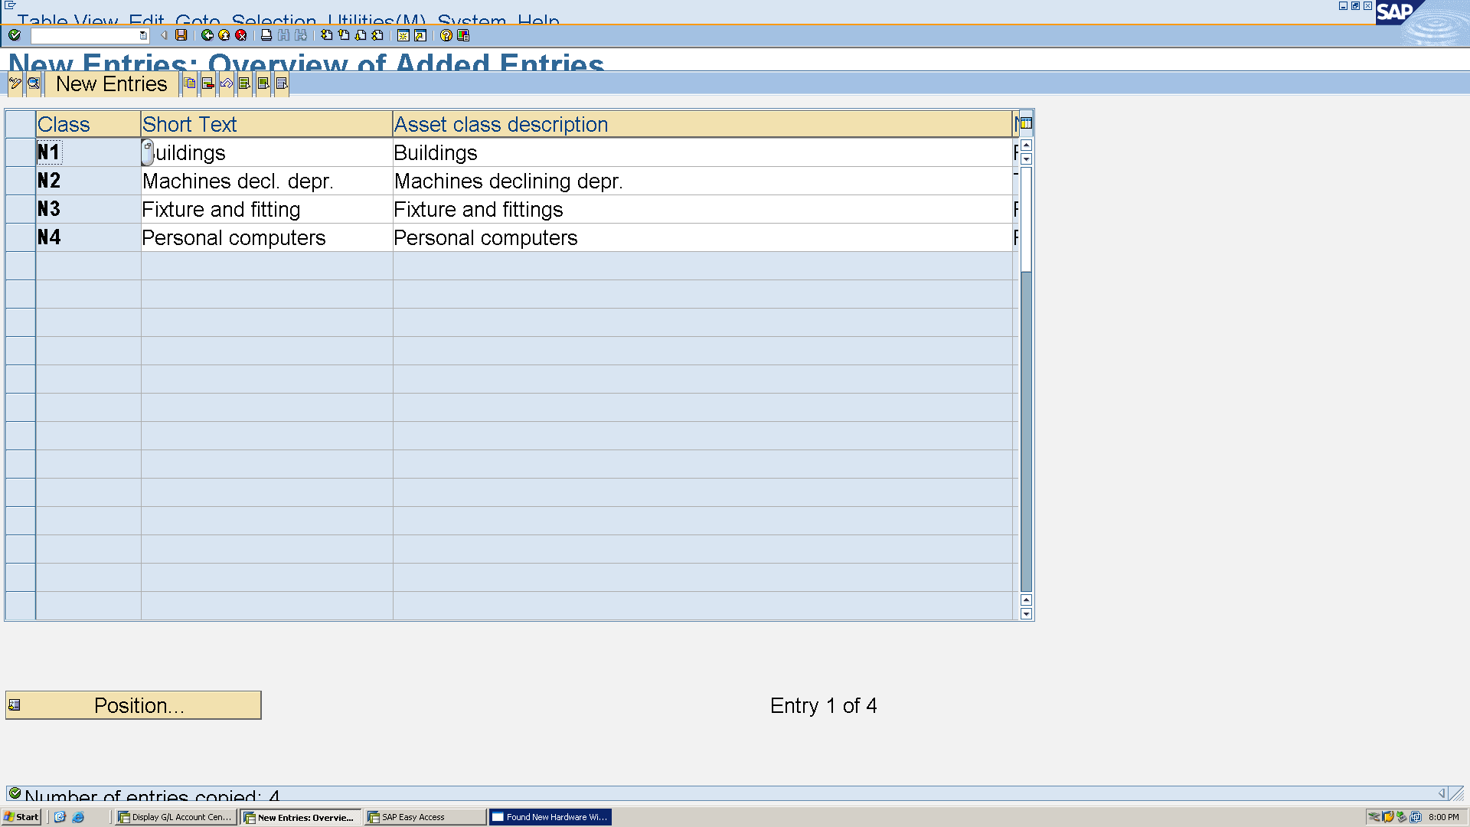Now to integrate wit GL T-code **AO90**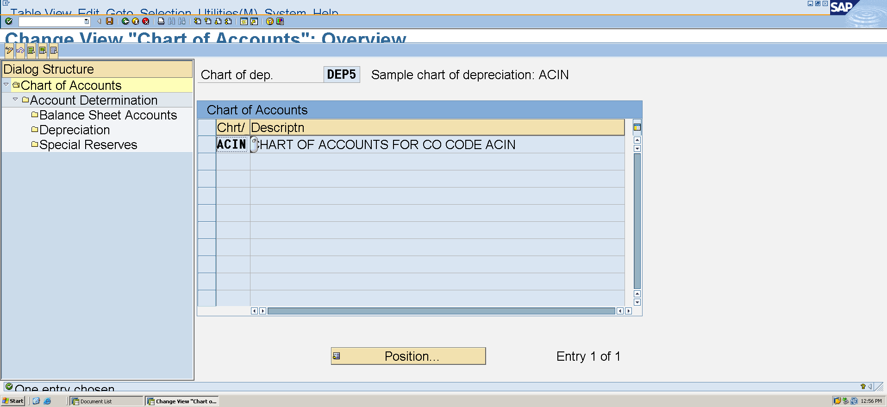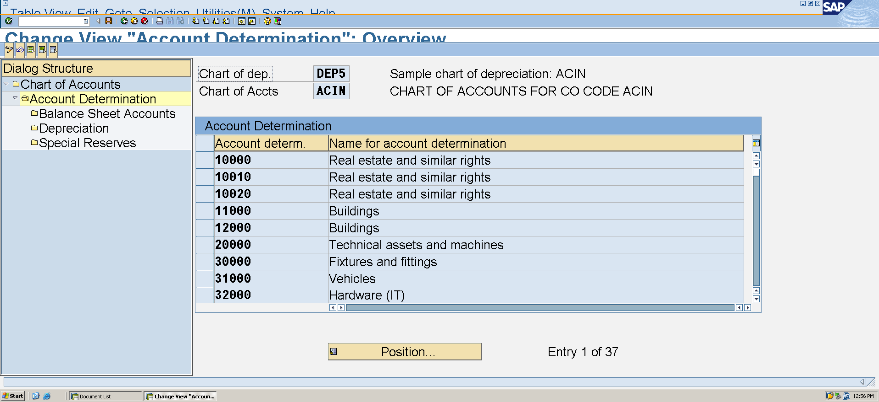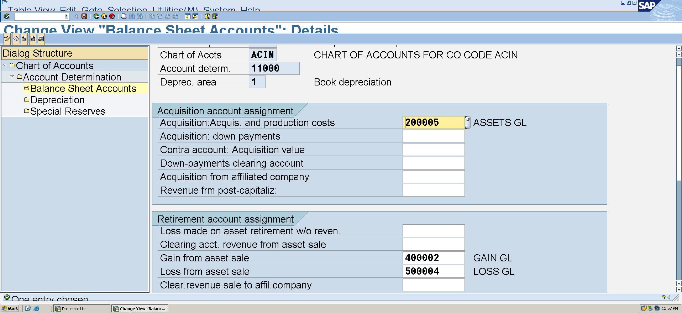To create Asset Code T-code **AS01**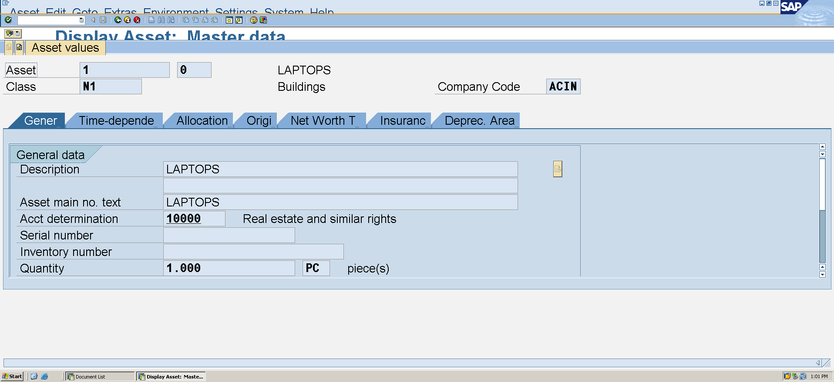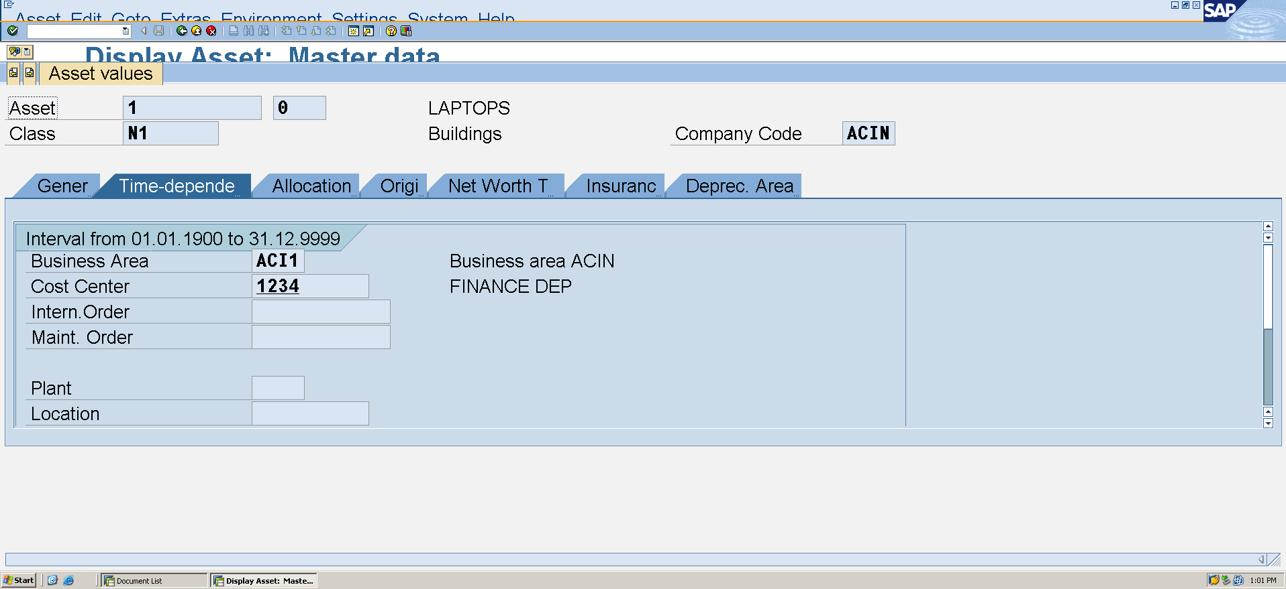To post Asset Acquisition t-code **F-90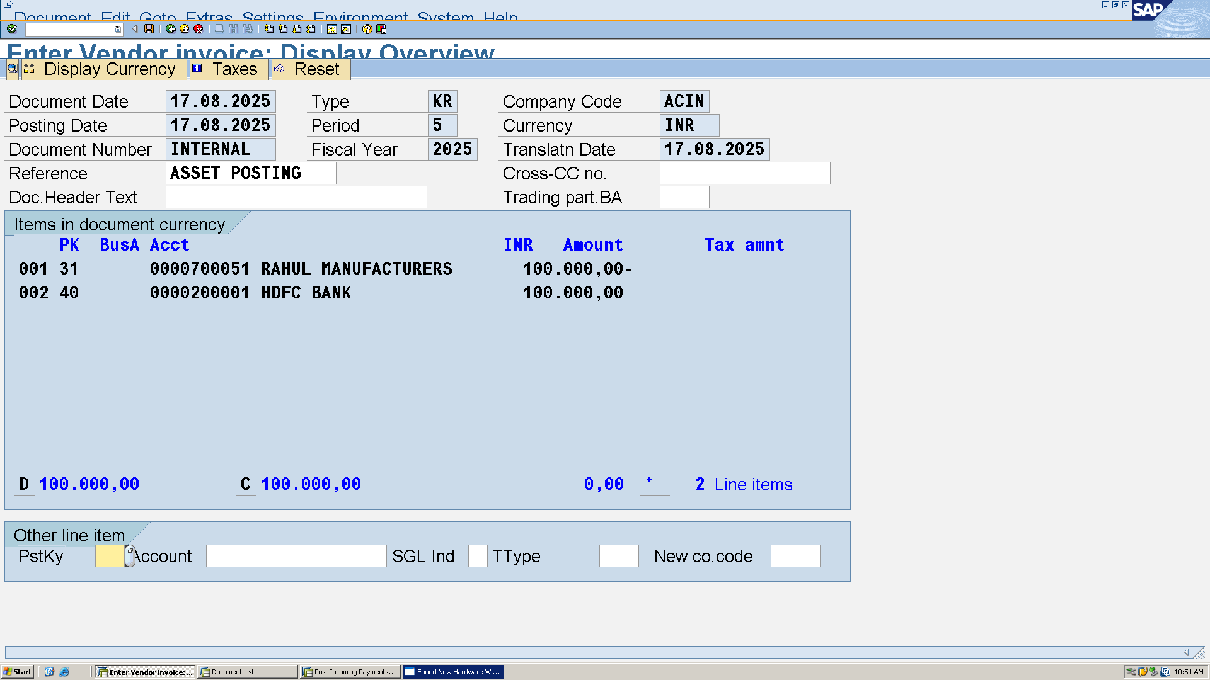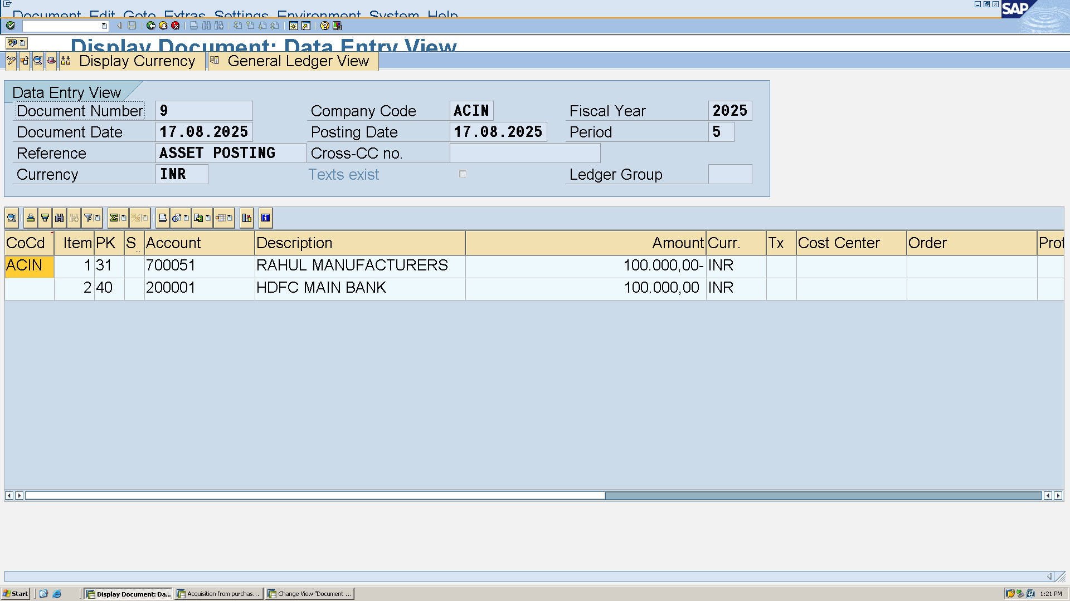 b. Periodic Postings**

Rent expense T-code **FB50**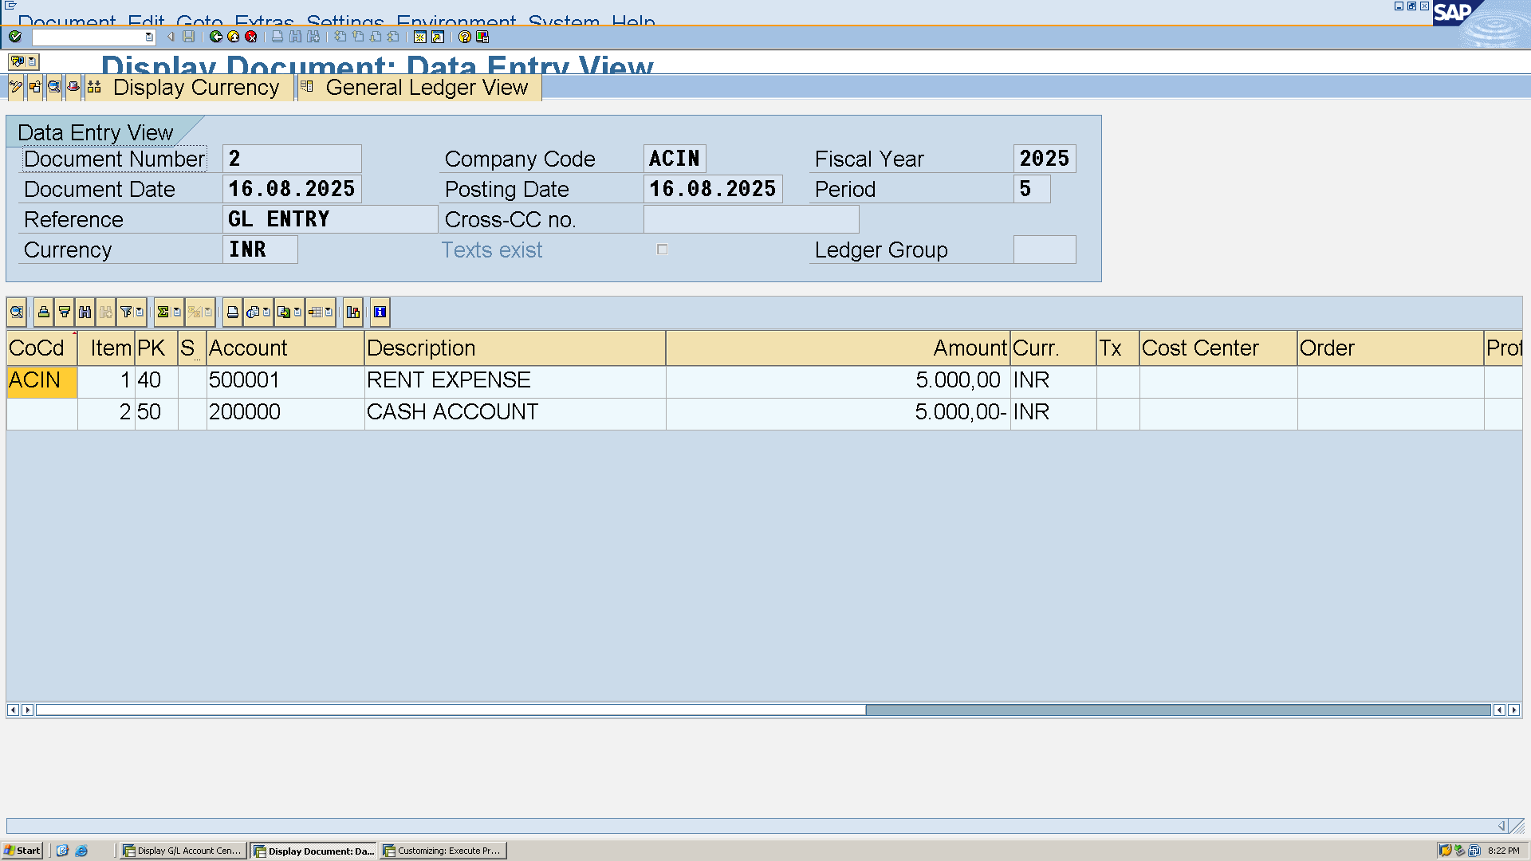Bank statement T-code **FF67** 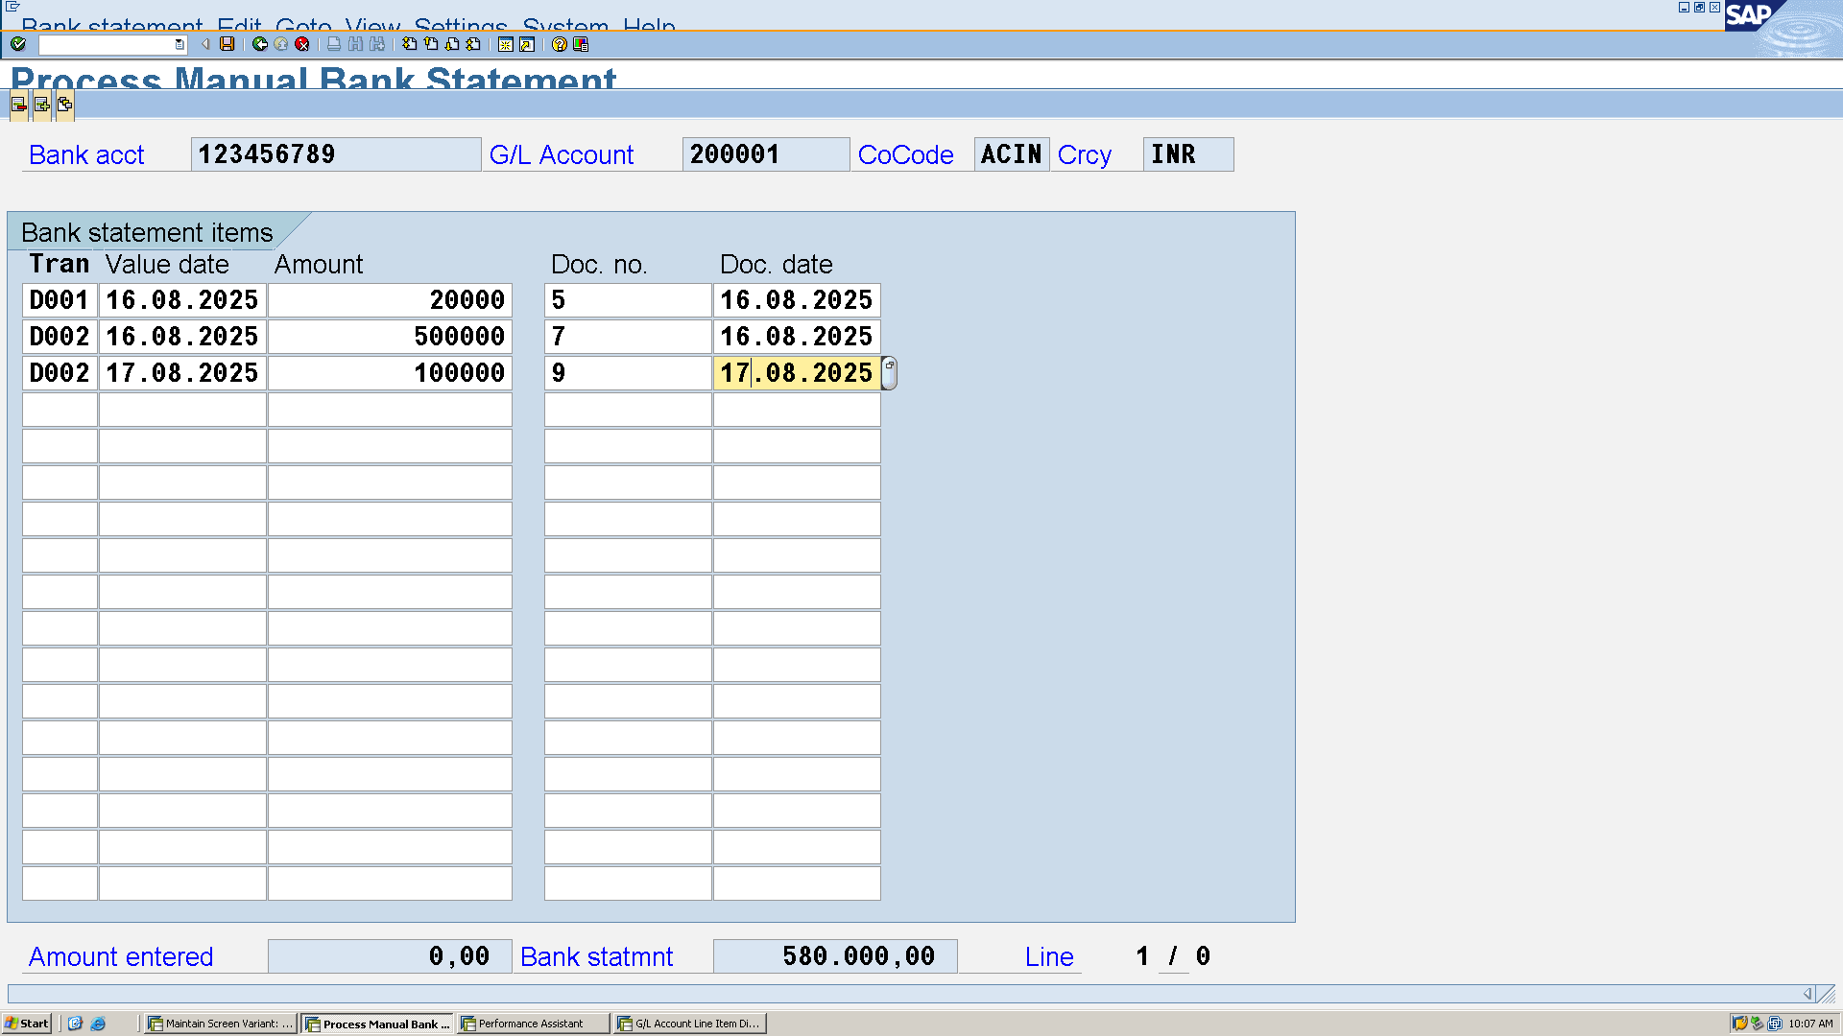

C. Supplier Invoice T-code **FB60**

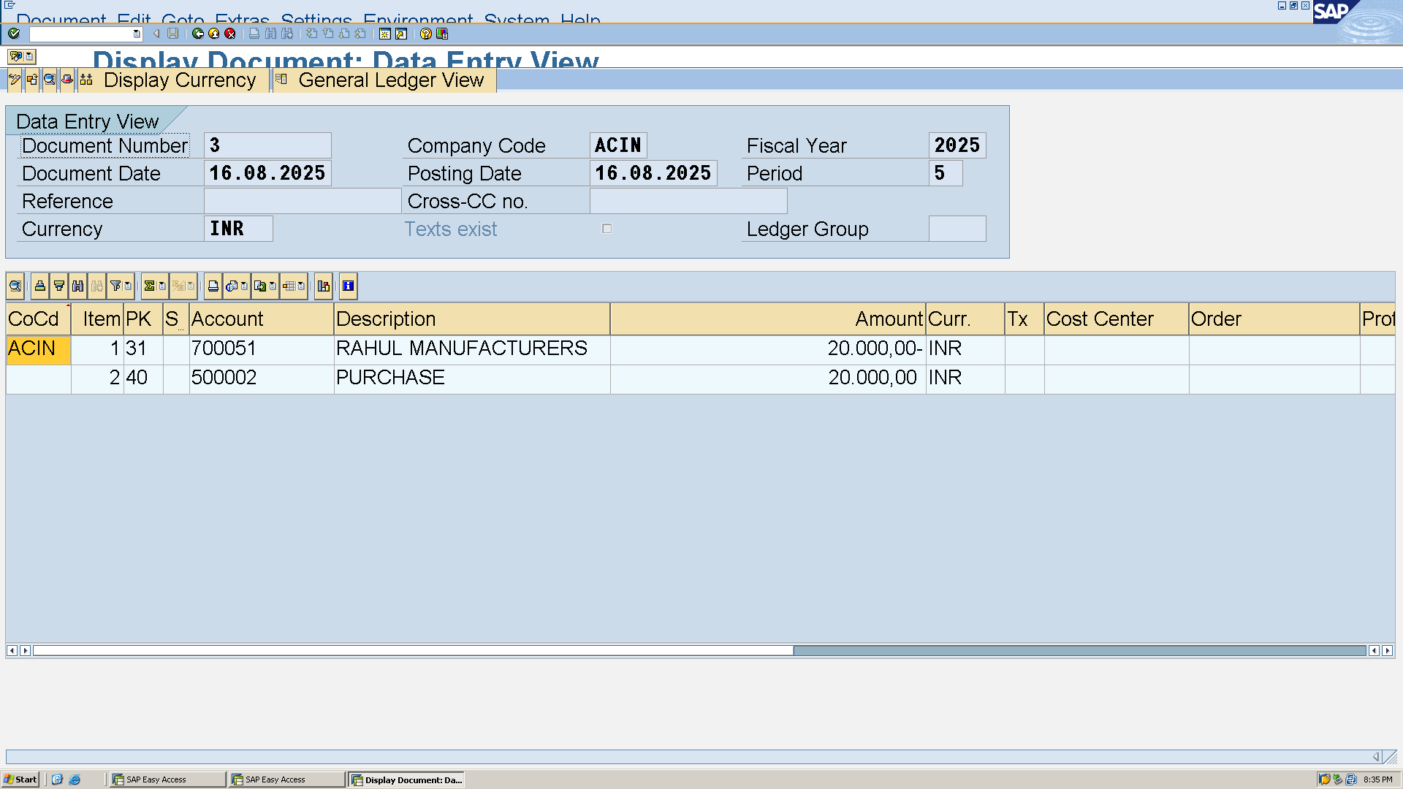 D. Customer Invoice T-code **FB70**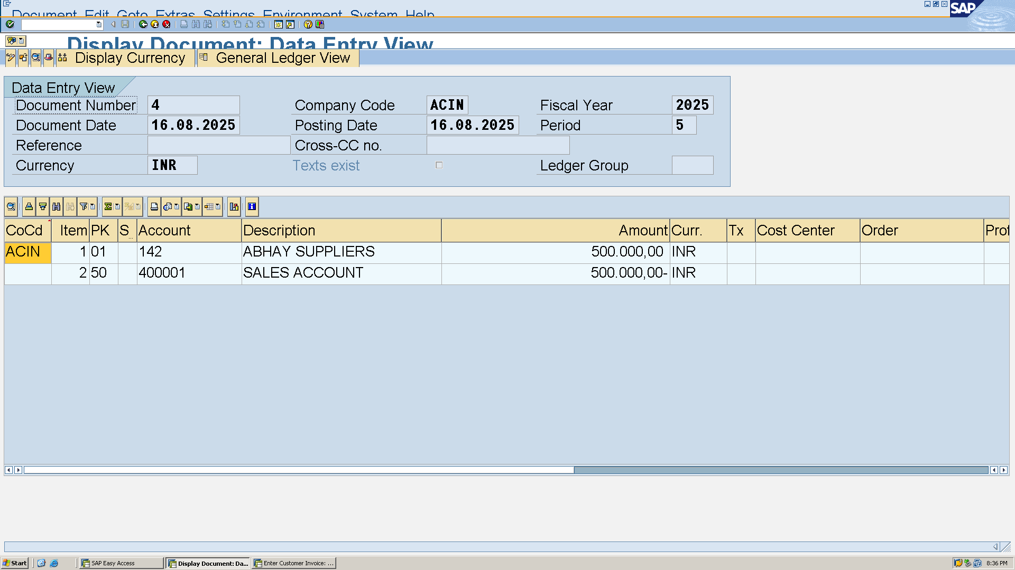

Outgoing payment T-code **F-28**

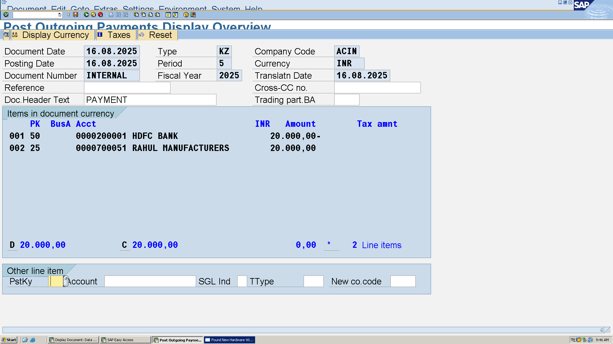To display document posted T-code **FB03**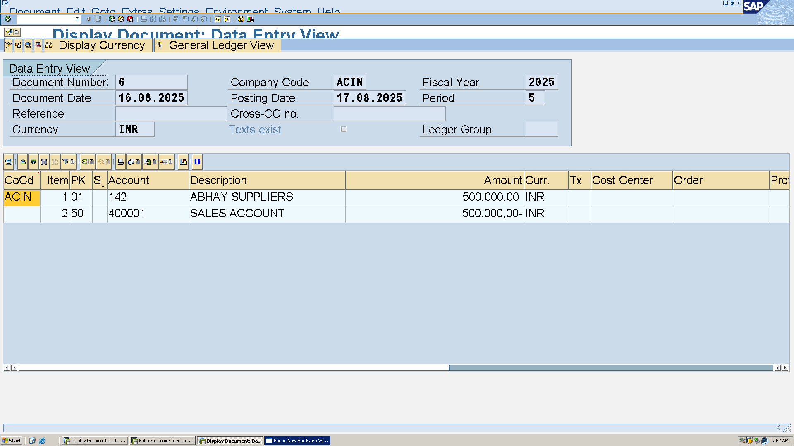 Incoming payment T-code **F-53**

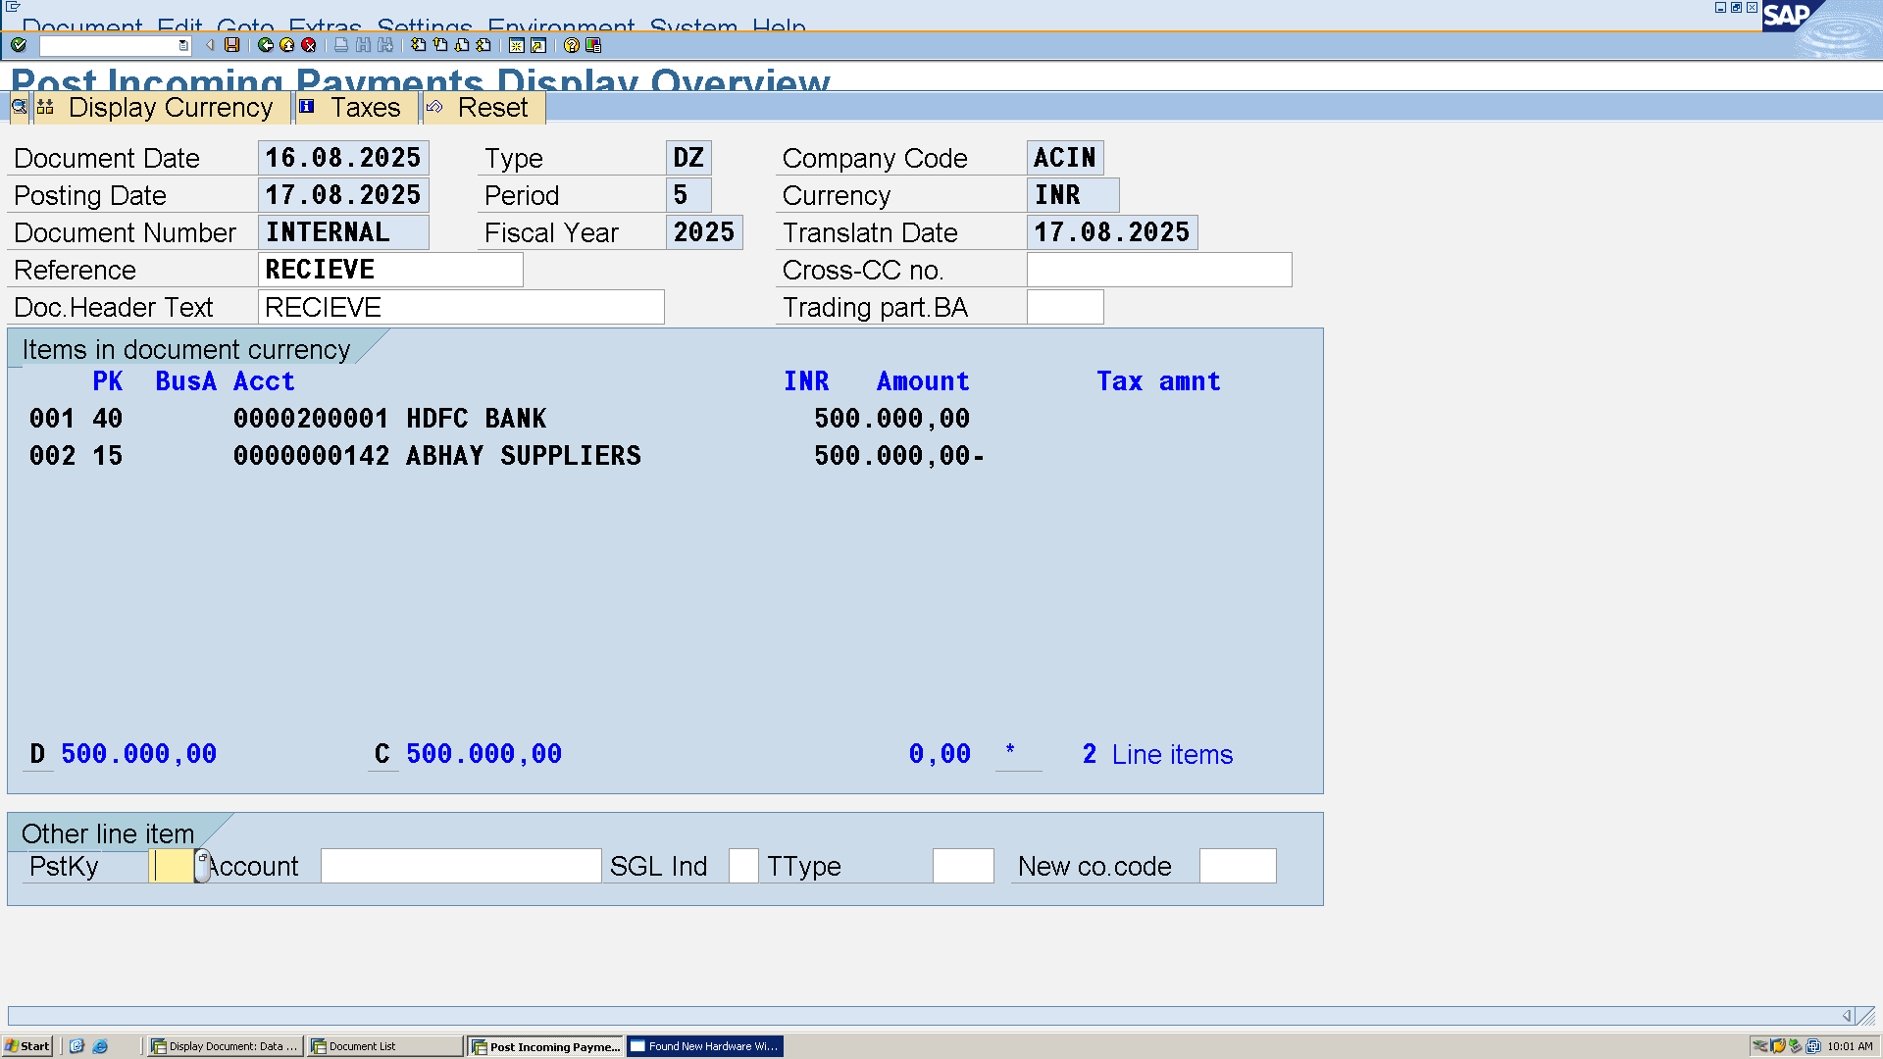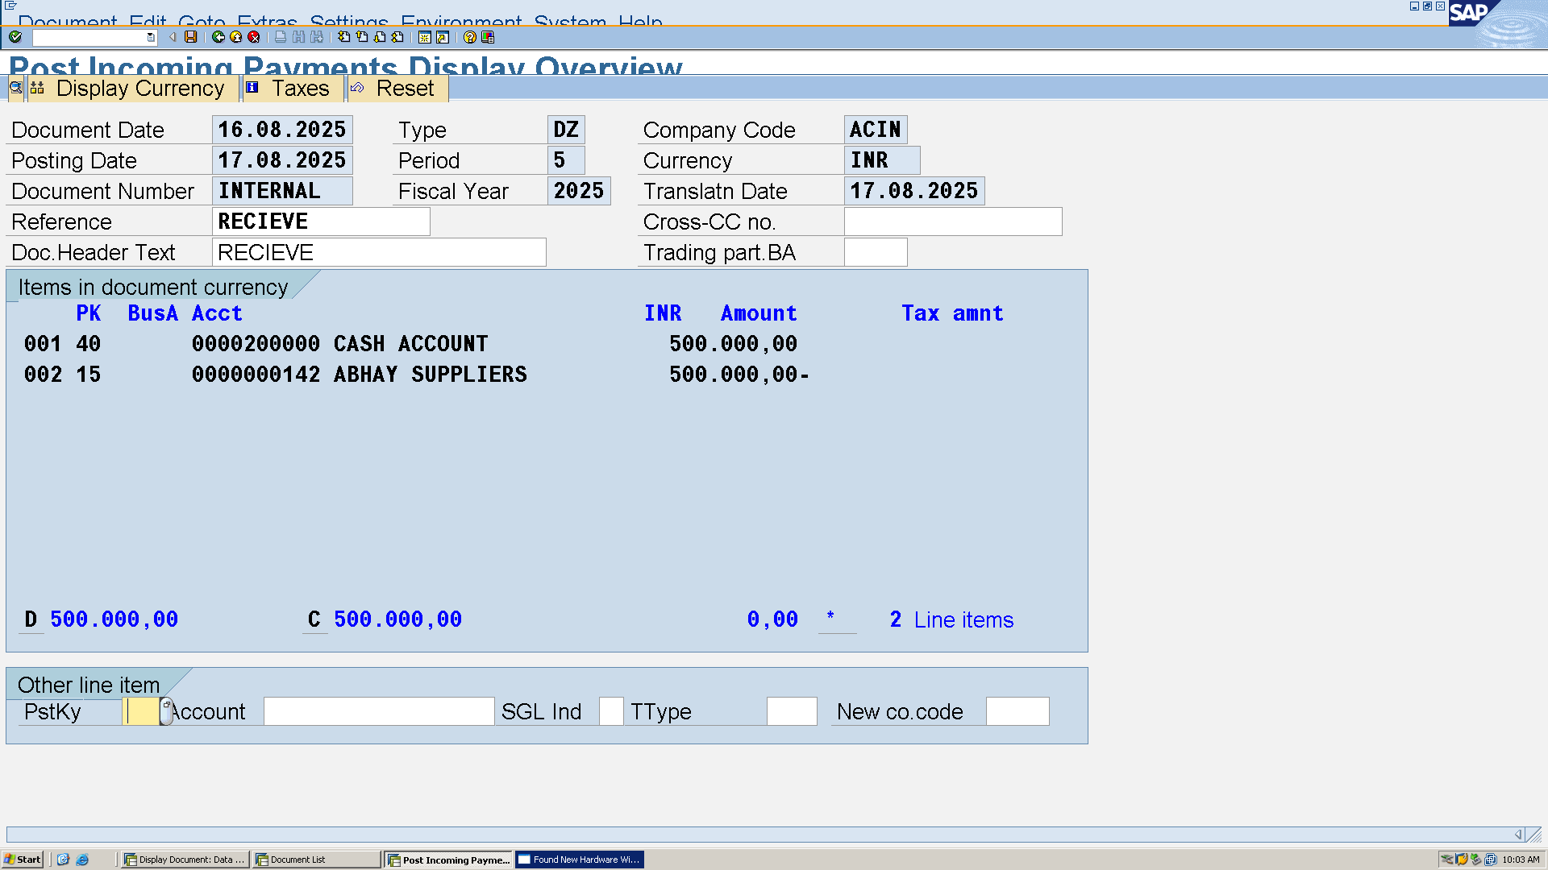 2.3 Financial Data Analysis

a. GL Account Balances : T-code **FBL3N or FS10N**

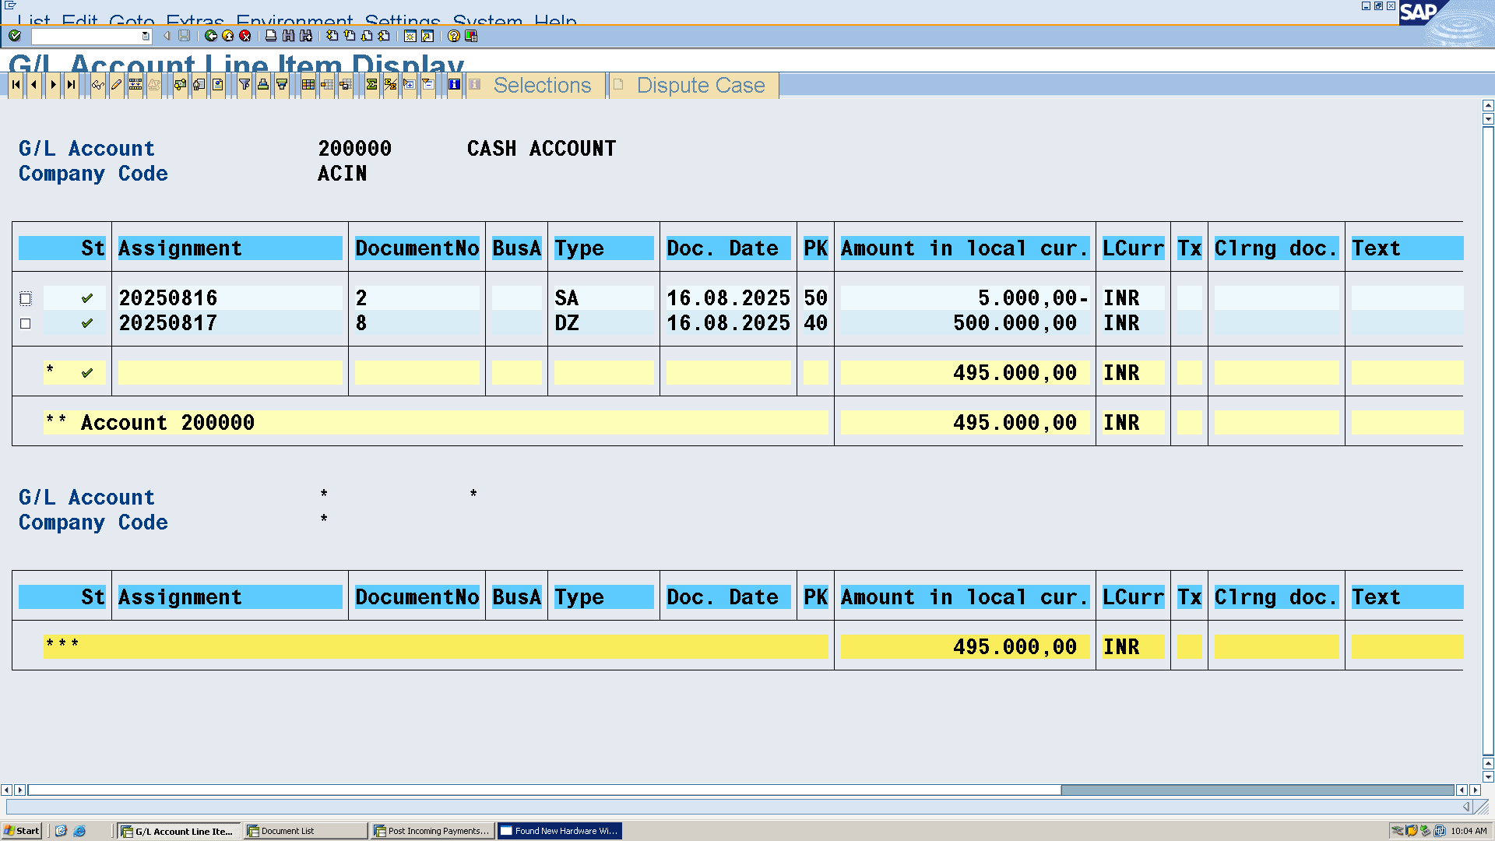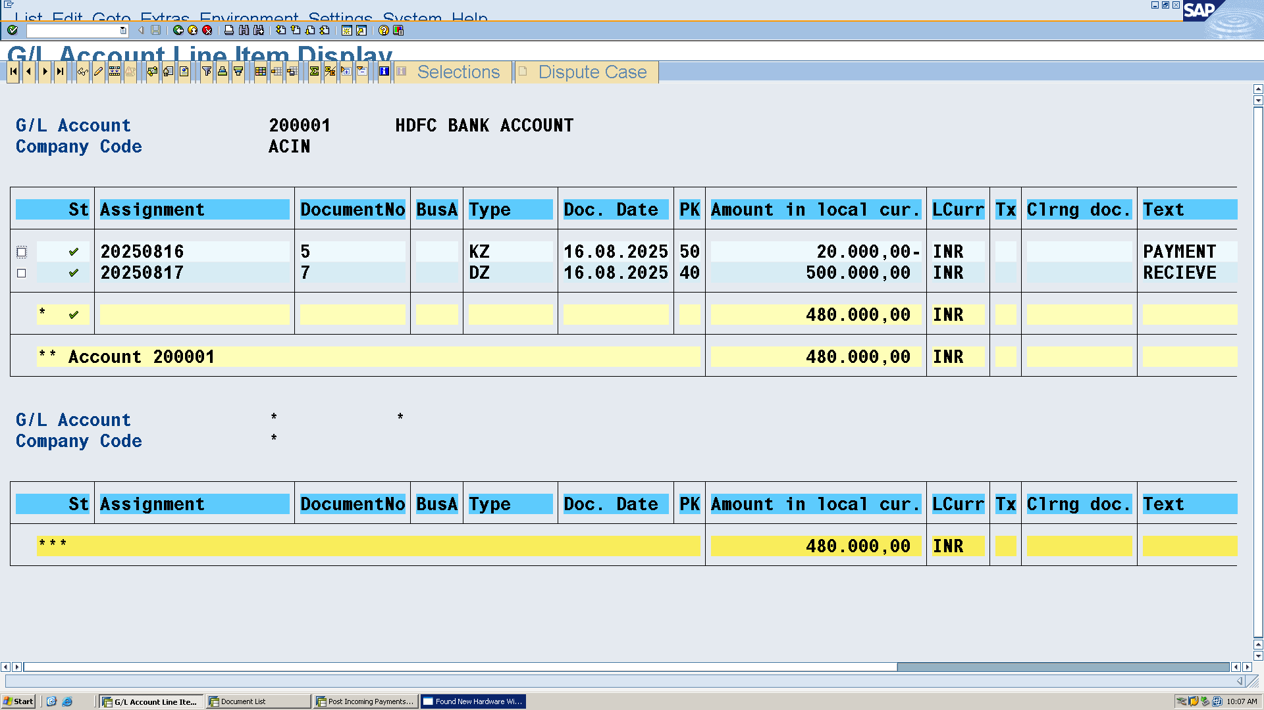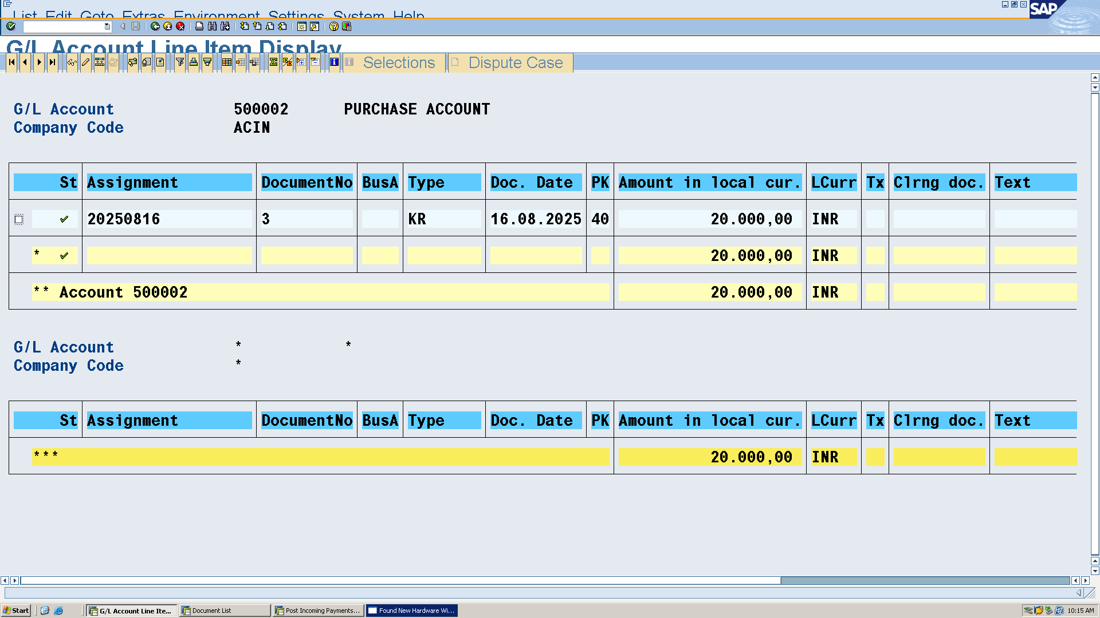 **b. Customer and Vendor Balances**

T-code **FBL1N** for Vendor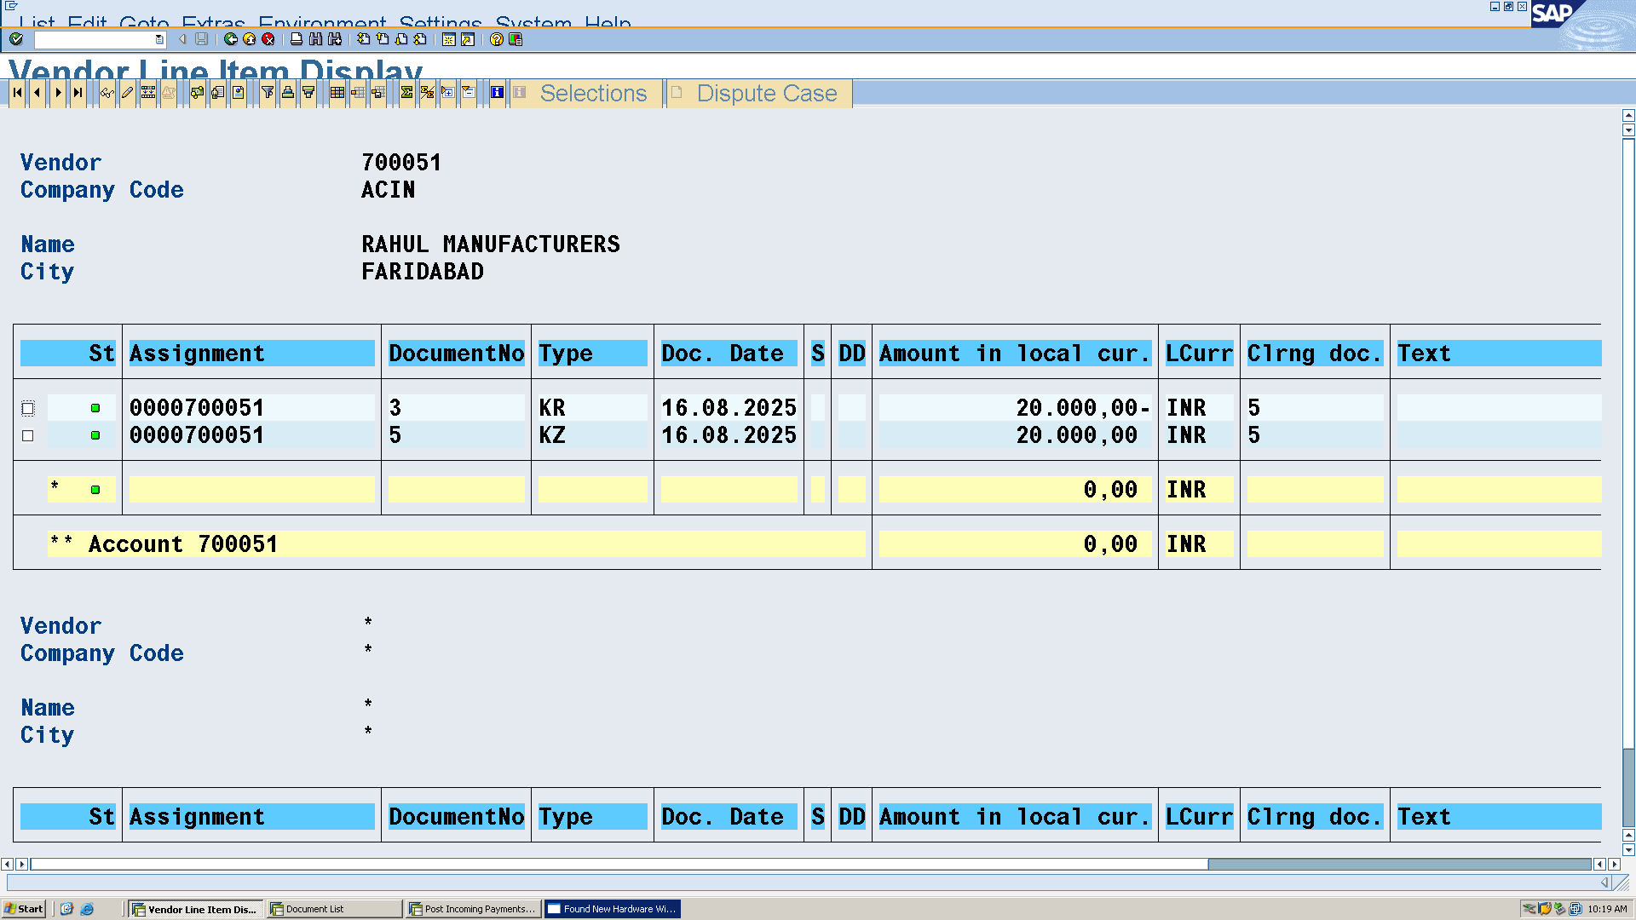 T-code **FBL5N** for Customer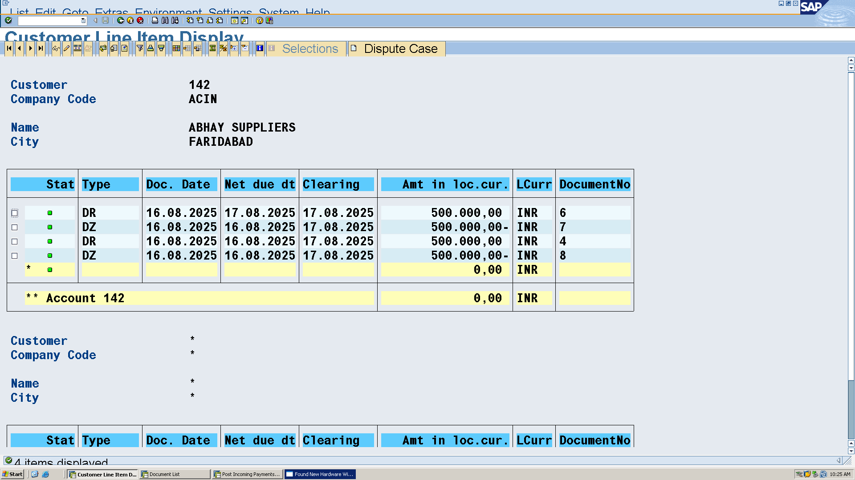 **c. Cost Center Analysis (not studied in class)**

**I had only studied to maintain controlling area cost element cost aenter accounting internal order and profit center.**

**d. Financial Statement Reporting T-code F.01 for Balance Sheet and P&L reports. 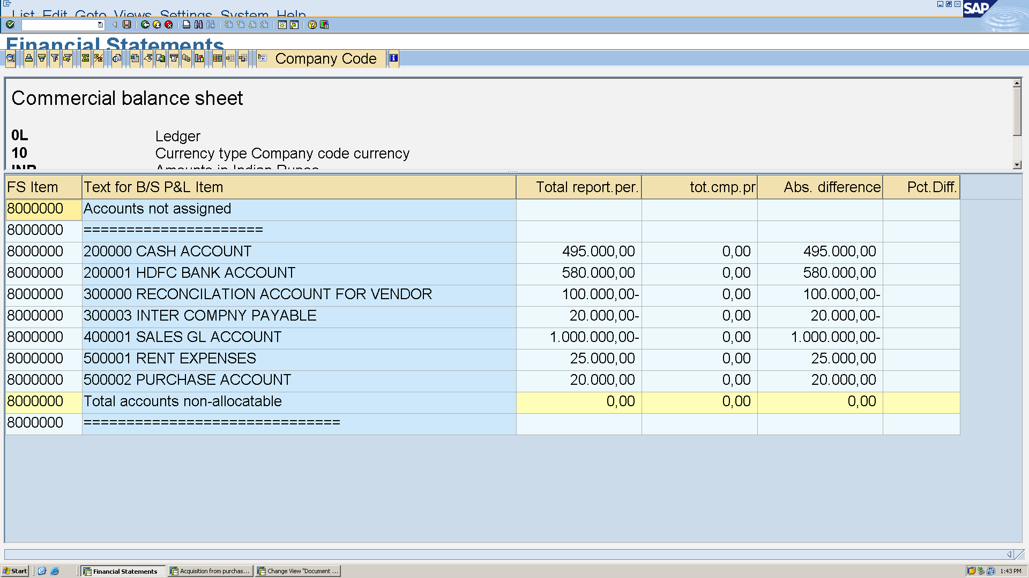 2.4 Advanced Topics**

**Intercompany Transactions: Simulate a purchase/sale between ACIN and another company code (e.g., CCCC), using T-code FB50 or F-02 for manual** **posting. 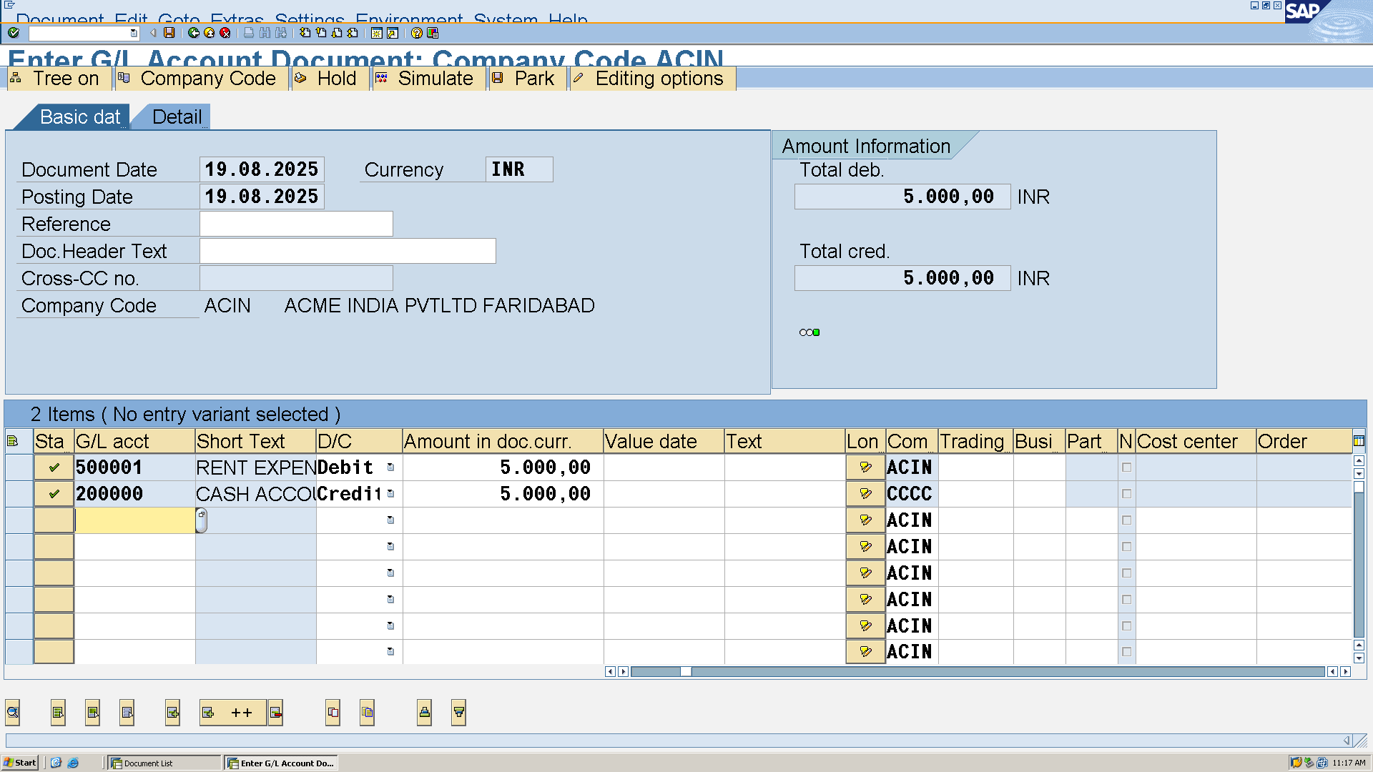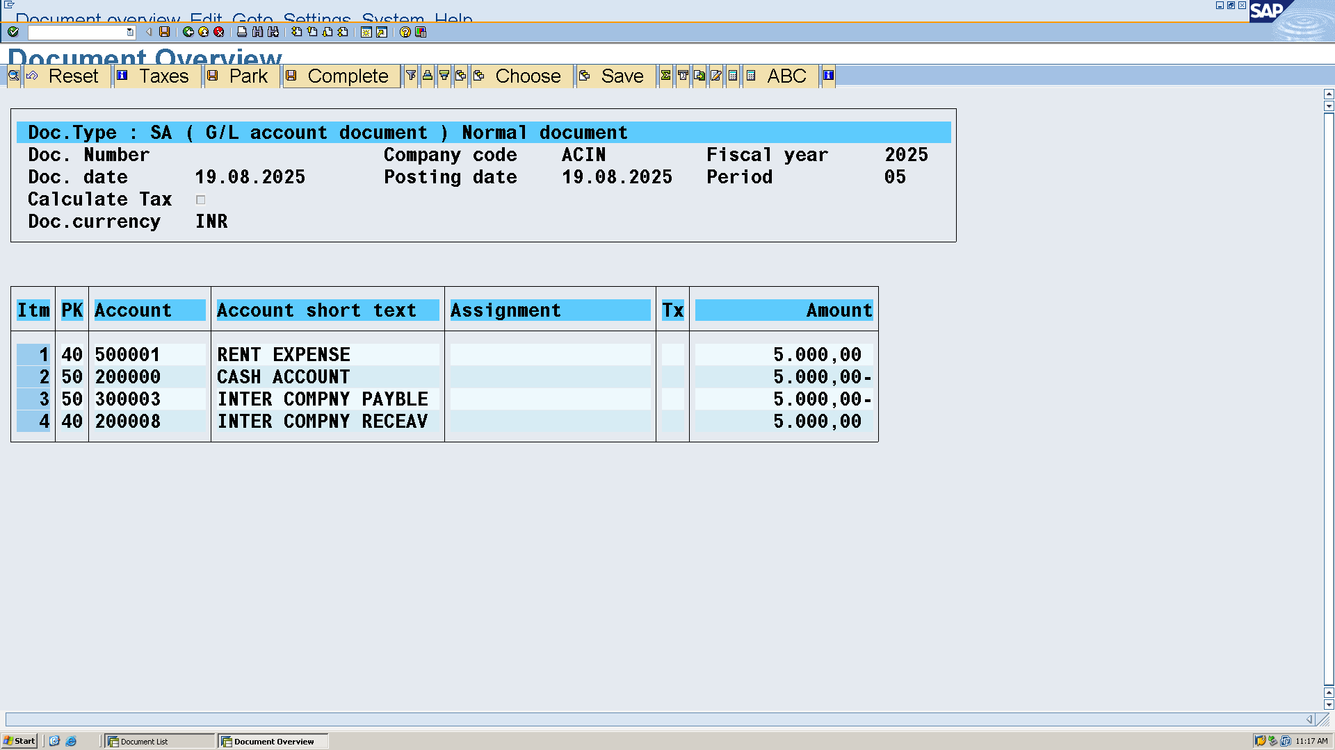 Currency Translation T-code OB08**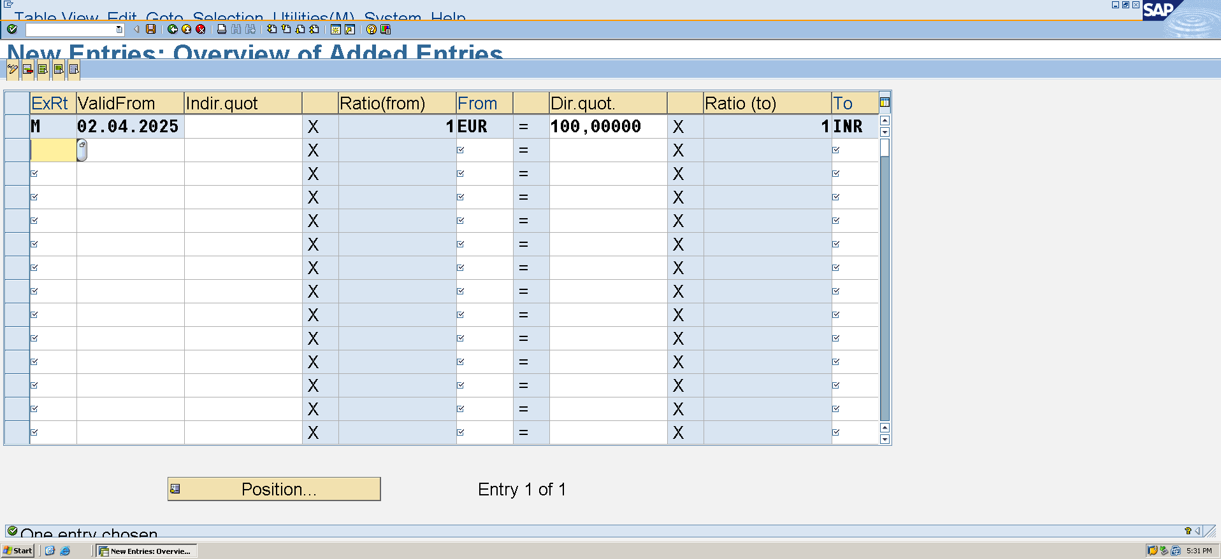

**Consolidation: Not studied in class**